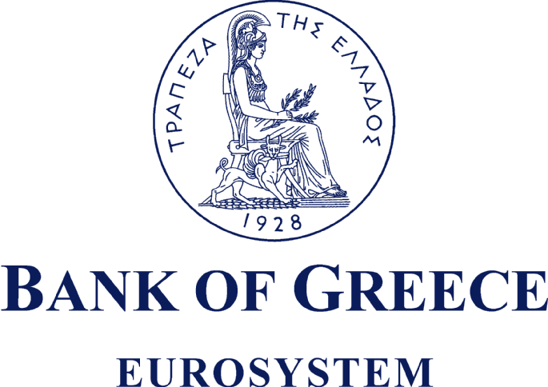
COMMEMORATIVE / COLLECTOR COINS
ORDER FORM *
 |  |  | Νο: |  |  |  | / |  |  | . |  | .
 |  |  | filled out according to the instructions of the Bank of Greece |  |  |  | (Date)
APPLICANT’S DETAILS
 |  |  |  |  |  | first name |  |  | surname |  |  |  |  |  |  |  |  | father’s first name
IDENTITY CARD OR PASSPORT NUMBER
METHOD AND PLACE OF PAYMENT
 |  | Please tick the appropriate blue cell |  |  |  | Bank of Greece Branch |  |  |  |  |  |  | by credit transfer
METHOD AND PLACE OF DELIVERY
 |  |  |  |  |  | by post
CONTACT DETAILS
 |  |  |  |  |  | tel. |  |  |  | mobile |  |  |  |  |  | fax
E-MAIL
DELIVERY ADDRESS (only for postal deliveries)
RECIPIENT’S FULL NAME
if other than the applicant’s |  |  |  |  |  | first name |  |  | surname |  |  |  |  |  |  |  |  | father’s first name
RECIPIENT’S ID CARD OR PASSPORT NUMBER
if other than the applicant’s
RECIPIENT’S ADDRESS
 |  |  |  |  |  | street |  |  |  |  |  |  |  |  | number |  | postcode |  | Country
RECIPIENT’S CONTACT DETAILS
if other than the applicant’s |  |  |  |  |  | tel. |  |  |  | mobile |  |  |  |  |  | fax
E-MAIL
if other than the applicant’s

 | COMMEMORATIVE COIN SERIES  (for full details, see  http://www.bankofgreece.gr/BoGDocuments/Κατάλογος_αναμνηστικών-ειδικών_κερμάτων.pdf) | PRICE | NUMBER OF PIECES** | VALUE
1 | ALBUM 12 COUNTRIES | €160
2 | BLISTER SET 2003 | €20
3 | TRIPTYCH BLISTER SET 2003 | €50
4 | SILVER COMMEMORATIVE COIN OF THE GREEK PRESIDENCY | €25
5 | BLISTER SET 2005 | €20
6 | TRIPTYCH BLISTER SET 2005 | €35
7 | BLISTER SET 2006 | €20
8 | TRIPTYCH BLISTER SET 2006 | €35
9 | SILVER COMMEMORATIVE COIN – BLACK PINE TREES | €40
10 | SILVER COMMEMORATIVE COIN – BIRDS | €40
11 | BLISTER SET 2008 | €20
12 | TRIPTYCH BLISTER SET 2008 | €35
13 | SILVER COMMEMORATIVE COIN – DION | €40
14 | SILVER COMMEMORATIVE COIN – DIAS (ZEUS) | €40
15 | BLISTER SET 2009 – 10th ANNIVERSARY OF THE EMU | €20
16 | BLISTER SET 2010 – BATTLE OF MARATHON | €20
17 | TRIPTYCH 2010 – SOFIA VEMPO | €35
18 | TRIPTYCH 2010 – INTERNATIONAL YEAR OF BIODIVERSITY | €35
19 | TRIPTYCH 2011 – SPECIAL OLYMPICS PANATHENAIC STADIUM | €35
20 | TRIPTYCH 2011 – SPECIAL OLYMPICS ACROPOLIS | €35
* To enter the required data, please place the hand cursor on the relevant blue cell, right click and select “Update field”; then type in and press “OK” |  | Shipping costs
 |  | Total amount payable
** The number of pieces is filled in by the applicant who, in signing below or sending this form by e-mail, acknowledges having read and unconditionally accepted the terms and conditions governing the sale and delivery of the coins that appear overleaf.

(Applicant’s signature) |  | (Place - Date)
Finalisation of the order by the Bank of Greece
(full names and authorised signatures)

Ι. TERMS AND CONDITIONS GOVERNING THE SALE OF COLLECTOR AND COMMEMORATIVE COIN SERIES
By decision of the Minister of Finance, the Bank of Greece is authorised, through its Head Office and Branches, to sell collector and commemorative coin series issued following a joint decision of the Minister of Finance and the Governor of the Bank of Greece.
As specified in the decisions currently in effect, interested parties may purchase, up to twenty (20) of blister sets or triptych blister sets or silver collector coins.
Detailed information regarding to the means of dispensation of the numismatic products to any interested party ( private collector – merchandiser ) are posted on DIAVGEIA as well as on the official website of the Ministry of Finance (www.minfin.gr) . Further information can be provided to any interested party by the relevant department of Ministry of Finance, - 25th Directorate Capital Transfer, Guarantee Loans and Securities of the General Accounting Office at the below referred telephone numbers: +30 210 3338 913, 210 3338 983, 210 3338 968 & 210 3338 967 and the following e-mail address : d25@glk.gr .
For the purchase of quantities within the limits specified above, the following procedure shall apply:
ΙΙ. EMAIL ORDERING PROCEDURE FOR SMALL QUANTITIES OF COLLECTOR AND COMMEMORATIVE COIN SERIES
1. Application submission
- First, the interested party shall fill out a Pre-Registration Form and email it to sec.tellers@bankofgreece.gr. Upon receiving the form, the relevant unit of the Bank of Greece shall verify that the items requested are still in stock and enter the details of the order into its pre-registration/order database. The Pre-Registration/Order Form will then be returned to the applicant with the following additional information from the Bank of Greece: (a) the Reference Number and Date of Pre-Registration/Order corresponding to the specific order; (b) indication of any non-availability of the items requested; and (c) the total amount payable by the applicant (including postage, ).
- In order to finalize the ordering procedure, the applicant will then have to prepay the full amount of the order, including postage if postal delivery is requested, within a deadline of three working days (starting from the Date of Pre-Registration). Otherwise, the order shall be cancelled.
2. Payment of the total amount due (for finalization of the order) can be done as follows:
- By money transfer (from a bank in Greece or abroad) to Bank of Greece Account No. GR2701000520000000059134368 – SALE OF COMMEMORATIVE COINS – BIC: BNGRGRAA. Important note: Field 70 of the money transfer order must mention the Reference Number and Date of Pre-Registration provided by the Bank of Greece to the applicant, as well as the applicant’s full name. Without this information, the Bank of Greece will not be able to match the money transfer to the corresponding pre-registration application and will not complete the procedure.
- At the counters of the Bank of Greece (Head Office or Branches): the applicant or person authorized to act on his/her behalf can, upon presentation of valid identification (ID or passport), pay the amount quoted in the Pre-Registration Form.
ΙΙΙ. DISPATCH OF COMMEMORATIVE / COLLECTOR COINS TO RECIPIENTS
- Orders for delivery shall be dispatched to recipients by registered mail via the Hellenic Post. The postage fees prepaid by the applicant shall be in accordance with the Hellenic Post rates in effect. The Bank of Greece shall not be responsible for any change in postage rates.
- In the event of non-receipt of an order, the liability of the Bank of Greece shall be limited to providing the customer with the relevant dispatch details (date and number) to enable tracing of the order. The Bank of Greece shall have no further liability to the customer.
- Please note that granted applications through remote orders can not be picked up by the Head Office or the Branches of Bank of Greece. Only postal delivery is available.
- In case that a remote order applicant for a numismatic product is found to have already purchased the certain product by the Head Office or any Branch of Bank of Greece, the remote order will be automatically cancelled and any such fee deposited will be returned to the applicant reduced by the money transfer fees. The above referred action will take place only when the quantity restrictions are valid.

