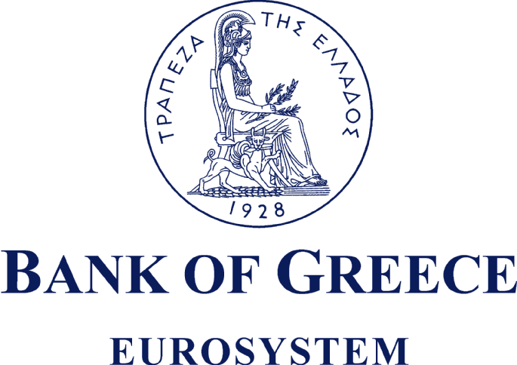

PRESS RELEASE

Athens, 11 March 2009

Subject: BALANCE SHEET AND PROFIT AND LOSS ACCOUNT FOR THE FINANCIAL YEAR 2008
At its meeting on 11 March 2009, the General Council of the Bank of Greece approved the audited Bank’s Annual Accounts for the financial year ending 31 December 2008.
The Bank’s net profit for the year 2008 amounted to €225.1 million, compared with €284.7 million in 2007, representing a decrease of 20.9%.
The lower net profit was mainly a result of increased provisioning against risks related to the Eurosystem’s monetary policy operations during the year 2008, as well as against future risks and other liabilities of the Bank.
The total dividend per share that will be proposed to the General Meeting of the Bank’s shareholders for distribution is €2.40, (2007: €2.56 per share, adjusted to the current number of shares, i.e. 19,864,886 shares).
In addition, a sum amounting to €22.2 million was transferred from 2008 profits to the ordinary reserve, which now stands at €111.2 million, equal to the share capital of the Bank, as required by Articles 10 and 71 of its Statute.
Analysis of the Profit and Loss Account for 2008
- Income
The Bank’s total net income in 2008 was slightly lower than in the previous financial year (having decreased by 0.2% to €823.5 million, from €825.5 million in 2007).
This result was solely due to the establishment of a new special provision against risks related to the Eurosystem’s monetary policy operations, whereas income from the Bank’s main sources increased significantly in 2008.
The special provision was established following a decision by the Governing Council of the ECB, given the exceptionally adverse conditions which prevailed in the money market during 2008 and affected also the Eurosystem’s liquidity-providing monetary policy operations.
In this context, the Governing Council of the ECB, in line with the general accounting principle of prudence, deemed it appropriate to establish a provision totalling €5,736 million as a buffer against counterparty risks in monetary policy operations.
In accordance with the Statute of the European System of Central Banks (ESCB) and of the ECB, this provision will be funded by all the national central banks of the participating Member States in proportion to their subscribed shares in the capital of the ECB.
Accordingly, the Bank of Greece established a provision of €149.5 million, which affected negatively the net result of pooling and reallocation of monetary income within the Eurosystem.
Developments in individual income categories:
● Net interest income amounted to €706.2 million, having increased by 30.6% from €540.9 million in 2007, as a consequence of the high returns on the assets included in the Bank’s portfolios.
● Net income from fees and commissions rose by 9.3% to €144.0 million, compared to €131.7 million in 2007. This income mainly concerns commissions received by the Bank from the Greek State for transactions conducted on the latter’s behalf, as well as commissions from the management of the Common Capital of Legal Persons in Public Law and Social Security Funds.
● Income from equity shares and participating interests increased by €34.8 million to €38.2 million, from €3.4 million in 2007. An important inflow under this item was the payment by the European Central Bank of €34.5 million, corresponding to the Bank’s allotted share of ECB’s seigniorage income and net profit.
● Net result of financial operations, write-downs and risk provisions fell by €67.3 million to €37 million, from €104.3 million in 2007. Results in 2007 had benefited from net realised gains of €93.4 million from swap operations, with which a special provision was created. It should be noted that 2008 saw higher realised gains from foreign exchange operations and debt securities, and significantly lower portfolio valuation losses as at year-end relative to 2007, despite the adverse international financial market environment.
Finally, other income, mainly comprising income from the activities of the Banknote Printing Works (IETA), amounted to €32.9 million, compared to €38.6 million in 2007.
- Expenses
Total expenses (excluding the provision against counterparty risks in the Eurosystem’s monetary policy operations) increased by 10.7% to €598.5 million in 2008, from €540.8 million in 2007.
This development was mainly due to an increase in provisions against future risks and other liabilities of the Bank.
Specifically:
● Other provisions (further to the aforementioned Eurosystem-related provision) set aside during the financial year 2008 rose to €197.4 million, from €148.1 million in 2007 (increased by 33.3%). The largest part of the amount of €197.4 millions relates to a provision against future counterparty risks arising from the conduct of Eurosystem monetary policy operations.
● Operating expenses excluding provisions (staff costs, pensions, administrative and other expenses, depreciation) increased by only 2.1% to €401.1 million, from €392.7 million in 2007. The respective increase for the previous year was 9.5%.

Developments in key balance sheet items during the financial year 2008
Increase in assets
The Bank's total assets grew by a substantial €28.3 billion in 2008, mainly reflecting the increased volume of liquidity provided to domestic credit institutions in the context of the single monetary policy of the Eurosystem.
Gold
The Bank’s total gold holdings represent a volume of 4.7 million ounces (146.4 tonnes), having increased slightly by 34 thousand ounces relative to the previous financial year. A significant increase was recorded in the euro value of these holdings which amounted to €2.9 billion as at 31 December 2008, from €2.6 billion as at 31 December 2007. The €270 million increase mostly stemmed from the rise in the price of gold.
The continuous rise in the market price of gold over the past few years has resulted in valuation gains totaling €1.2 billion. This amount, which has been transferred and maintained in a revaluation account, represents a buffer against any future valuation losses on the Bank's gold holdings.
The Eurosystem’s monetary policy
In the course of 2008 and in the context of its single monetary policy, the Eurosystem contributed with its interventions to restoring financial stability.
● The Governing Council of the ECB lowered the interest rate on the main refinancing operations in successive steps from 4.25% where it stood in October 2008 to 2.5% by the end of 2008. It has subsequently been lowered twice during 2009 and now stands at 1.5%.
● At the operational level, the Eurosystem intervened extensively in the money market and supplied the banking system with substantial amounts of liquidity.
In this context, the Bank of Greece, as a member of the Eurosystem, conducted liquidity providing operations with domestic credit institutions against adequate collateral.
The Bank’s net lending in euro to domestic credit institutions increased by €29.6 billion to €35.5 billion as at 31 December 2008, from €8.2 billion as at 31 December 2007.
In addition, the Bank provided liquidity in US dollars, under a swap agreement between the ECB and the Federal Reserve which aimed to provide short-term US dollar funding to euro area credit institutions. The related outstanding balance of credit in US dollars was €2.2 billion as at 31 December 2008.
Euro banknotes in circulation
The Bank’s share in total euro banknotes in circulation increased by €2 billion to €18.3 billion as at 31 December 2008, compared with €16.3 billion as at 31 December 2007. This increase can be attributed to the €86 billion rise in the total value of euro banknotes in circulation both inside and outside the euro area. As at 31 December 2008 they amounted to €763 billion, compared to €677 billion as at 31 December 2007.
Portfolio management
Throughout the financial year 2008 the bulk of portfolios under the Bank’s management continued to consist of euro-denominated debt securities issued by governments of euro area countries, including Greek government bonds. This asset allocation strategy ensured limited exposure to foreign exchange and security price risks, as well as high yields.
Increase in the share capital and the ordinary reserve
The Bank’s share capital was increased by €22.2 million in 2008, with the capitalization of part of real estate revaluation gains. The increase was effected by the issuance of 3,972,977 new bonus shares of a par value of €5.60 each, which were allotted to current shareholders in a proportion of one new share for every four existing shares. The ordinary reserve was increased by the same amount, so as to remain equal to the share capital as required by the Bank's Statute.
Provisions
In 2008, the Bank increased further its provisions against risks and future liabilities. Total provisions amounted to €1,506.8 million on 31 December 2008, compared with €1,173.6 million on 31 December 2007.
Organisational restructuring of the Bank
The organisational restructuring of the Bank continued during 2008. The Bank's Administration proceeded with organisational changes in several business areas, taking into account the new conditions within the Eurosystem.
The steps taken in 2008 concerned changes in the structure of a number of business units of the Head Office in Athens and a reduction in the network of the Bank’s Branches and Agencies in other parts of Greece. Similar steps will follow in the coming years.
It should be noted that similar restructuring and downsizing programmes have been or are being implemented by almost all other national central banks of the Eurosystem.

