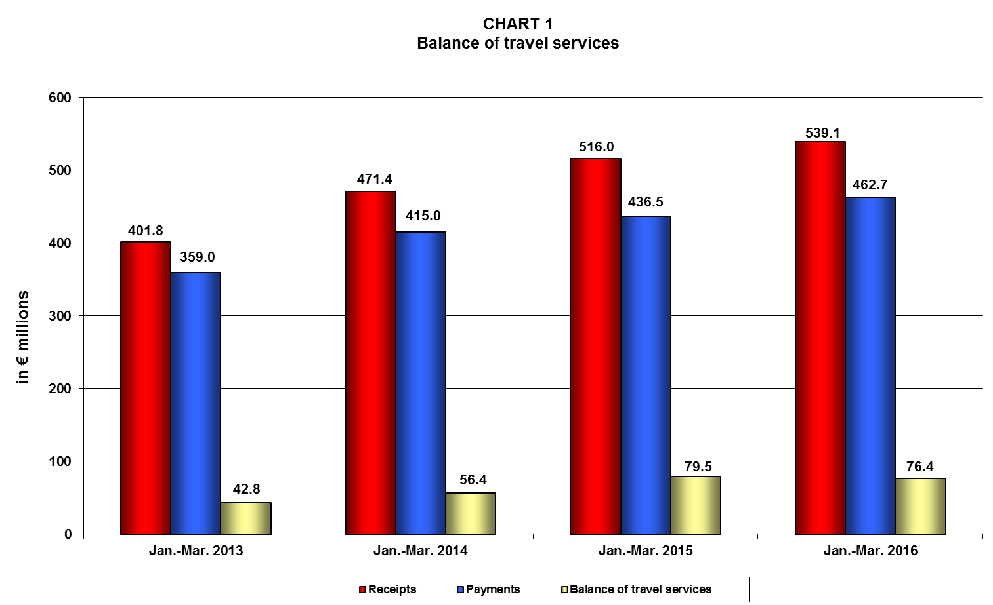
Note: Percentage changes may not add up due to rounding.
* These figures include cruise data collected from sources other than the Border Survey “non-BS cruise data”. For these data, a breakdown by country of origin is not available.
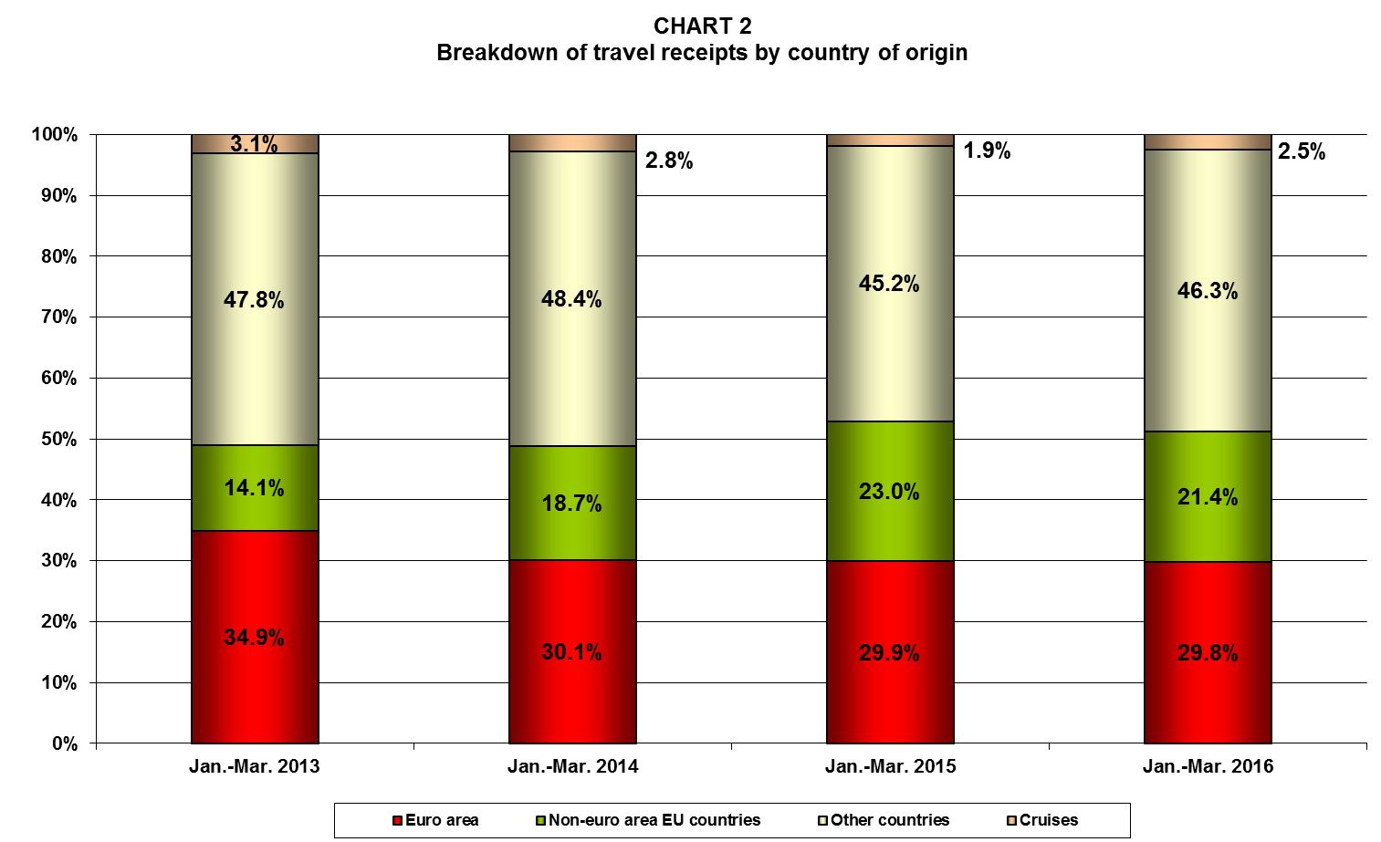

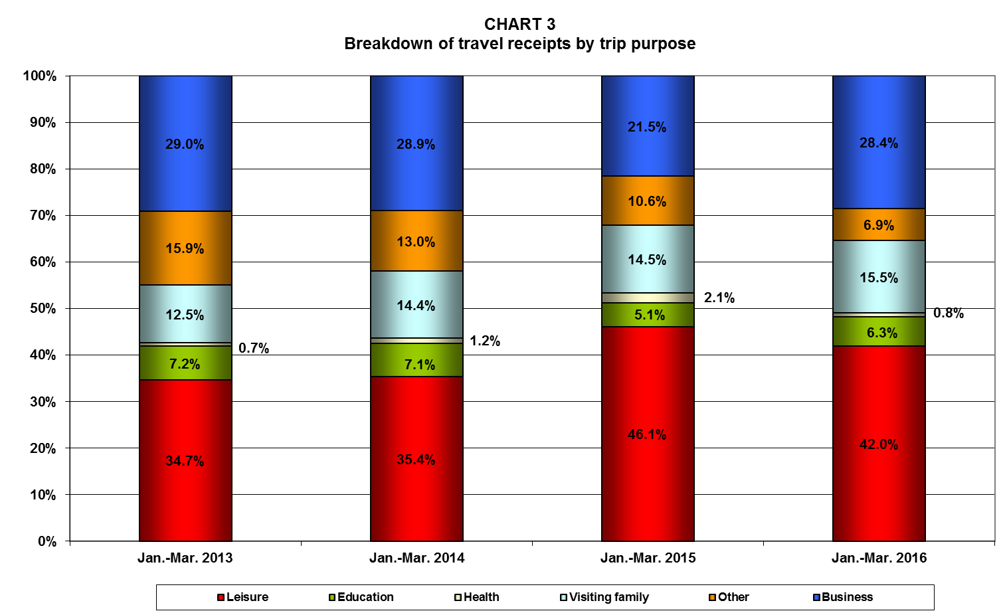

* These figures include cruise data collected from sources other than the Border Survey “non-BS cruise data”. For these data, a breakdown by country of origin is not available.

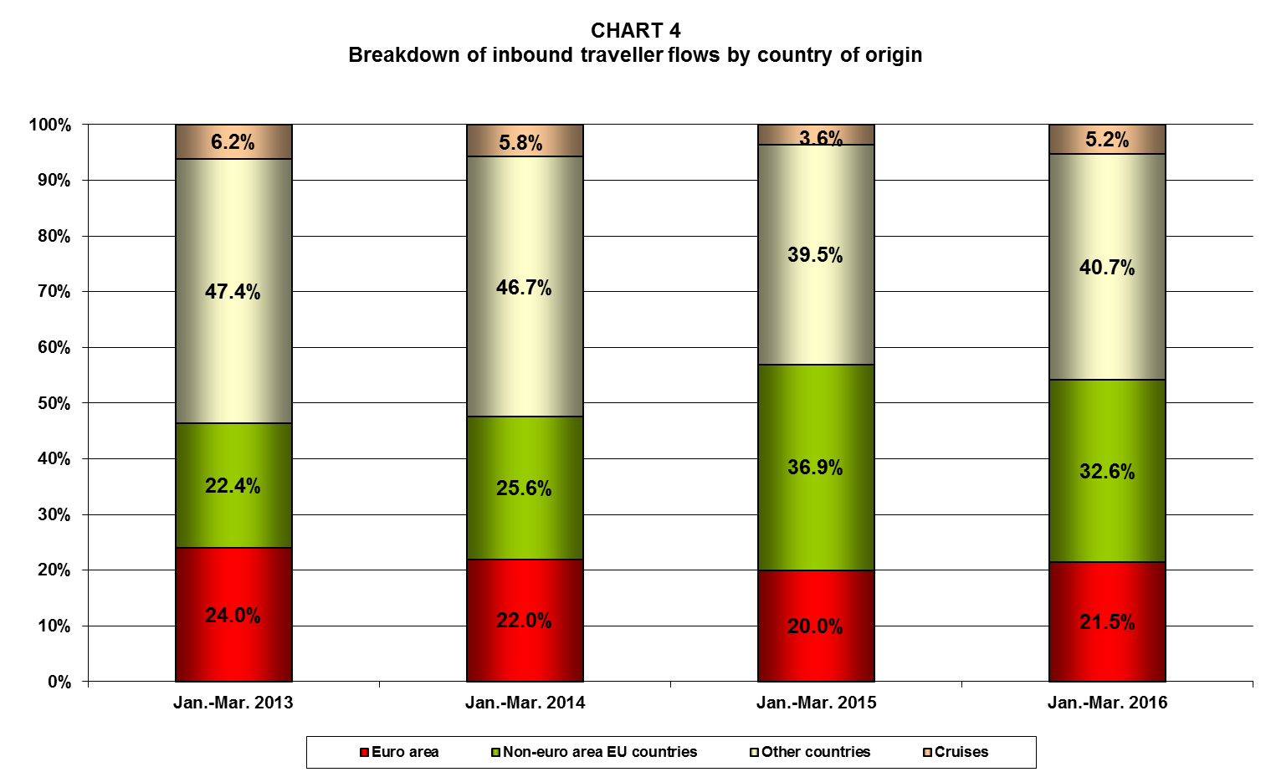
* These figures include cruise data collected from sources other than the Border Survey “non-BS cruise data”. For these data, a breakdown by country of origin is not available.
Note: Each same-day visit, irrespective of duration, is assigned one overnight stay.
