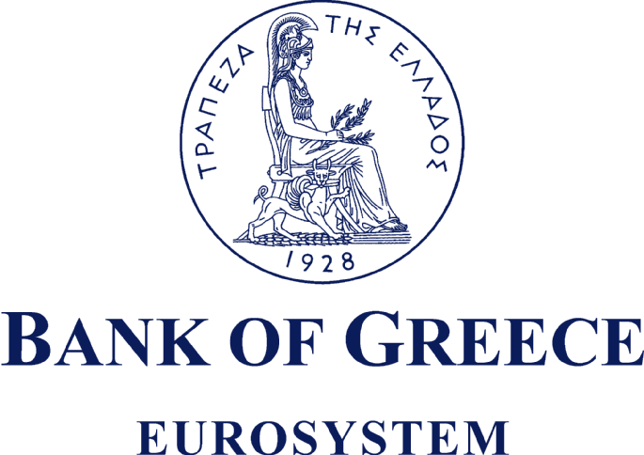

“Recent financial market developments and implications for the euro area and the world economy”

Keynote Speech by Governor Nicholas C. Garganas

Meeting of the International Chamber of Commerce (ICC) Commission on Banking Technique and Practice

Athens, 16 April 2008

It is a pleasure indeed to welcome you to Athens for this meeting of the International Chamber of Commerce Commission. This meeting is taking place at a time of turmoil in global financial markets and a significant downturn in global economic growth. I am delighted to have this opportunity to offer some remarks about the present situation and the challenges ahead.

We are living in the era of the great globalization and the ICC has been an invaluable voice championing the benefits - - including enhanced economic growth, prosperity, and job creation - - of increased economic and financial integration. While globalization brings important benefits it also, sometimes, brings heightened risks and uncertainties, as recent financial market developments vividly illustrate.

The last nine months have been a very challenging period for both policy makers and market participants. During this period, we have witnessed a major reappraisal of risk and a considerable, and still ongoing, turmoil in key financial markets. We have also seen - - especially in the US and, to a lesser extent, in the euro area and the rest of the world - - downward revisions of growth prospects amid increased risks and uncertainties. In order to be able to ensure that the full benefits of globalization are shared by our citizens, it is necessary to be able to manage the risks and uncertainties associated with globalization. My remarks today, will deal with the origins of the ongoing financial markets turmoil, the policy responses to this turmoil, mainly by the major central banks, and prospects and policy challenges for the euro area and the global economy in the light of this turmoil.

Greece will, therefore, not be the focus of my remarks this morning. Let me just note that Greek banks generally have a relatively comfortable capital base and strong profitability, their exposure to U.S. sub-prime mortgage loans has been negligible, while the impact of the international financial market turmoil on the Greek banks has so far been indirect and rather contained. However, the financial market turmoil is far from over and there are still risks ahead of us. For this reason, the Bank of Greece has urged financial institutions to be especially prudent in their portfolio management.

Origins of the current financial market turmoil

Although the financial market turmoil was triggered by problems in the sub-prime loans of the U.S. mortgage market, the origins of this turmoil can be traced to earlier developments. In the four-year period to mid-2007, the world economy had been characterized by exceptionally benign macroeconomic and financial conditions, as indicated by strong growth and low levels of inflation and (long-term) interest rates. Such conditions of “low volatility” fostered a “search for yield”, a rise in leverage to increase returns further, and an under-pricing of risk in some key asset markets. These developments were supported by - - and, in turn, they encouraged - - further financial innovation, as evidenced by the rapid growth in securitization of bank loans, in credit risk transfer instruments and in other complex structured finance products.

Rapid financial innovation over the last 30 years has undoubtedly benefited the world economy by allowing a deepening of capital markets, easier access to credit by households and enterprises, and a more effective utilization of resources. However, especially in recent years, financial innovation has also been associated with structural weaknesses and complacency in risk management. For instance, the low transparency of these complex products may have made it easier for investors to underestimate the risks they take on. In addition, with prudential regulation sometimes lagging behind financial innovation, some institutions may not have been sufficiently transparent about their exposures to complex structured finance products, on and off their balance sheets. Moreover, as such products were often difficult to value owing to inadequate information about the underlying assets, investors often relied too heavily on credit rating agencies. However, the methodology used by the credit rating agencies was not transparent, failing to identify the risk characteristics of the complex structured finance products, including their illiquidity. It is also well known that it was the distorted incentives in the “originate-and-distribute” business model of financial institutions that led to a decline in credit standards, the root cause of the “sub-prime” problem. More generally, the extent of leverage taken on by banks, bond insurers, hedge funds, and other financial institutions was probably not adequately appreciated, nor were the risks of a disorderly unwinding.

Eventually something was bound to happen that would trigger a widespread reappraisal of risk, resulting in re-intermediation and de-leveraging. This turned out to be the escalating losses on US sub-prime loans, which showed up in certain hedge funds and structured investment vehicles (SIVs) in the US and in Europe in mid-2007. Subsequently, the market tensions spread through the market for structured finance products and asset-backed commercial paper to the key interbank money markets in Europe and the US, the core of the international financial system.

Central bank policy reaction

Since last August, the major central banks - - including the ECB, the Bank of England and the U.S. Fed - - have responded to the liquidity squeeze in the interbank money markets by expanding the scale and scope of their routine operations. They have injected extra liquidity, lengthened the maturity of their lending facilities, and (in the case of the Fed) expanded the list of counterparties and widened the range of acceptable collateral in their operations. These actions have contributed to a significant improvement in money market conditions since late December in the euro area, the UK and the US.

Nevertheless, there remains much uncertainty in the market about the liquidity and capital adequacy positions of financial institutions, which has implied the need for continued central bank operations. Some large financial institutions - - notably in the U.S. and in non-euro-area Europe - - have already acknowledged large losses in their balance sheets over the past few months, necessitating capital injections (e.g., by Citibank and UBS) or acquisitions by other, financially strong institutions (e.g., that of Bear Stearns by JPMorgan Chase). Financial institutions have generally attempted to acknowledge their losses and appropriately value their balance sheets but there are difficulties in properly valuing some complex financial assets, not least because markets have often ceased to operate properly for such assets. There is thus a risk of potential future losses, which has maintained a climate of uncertainty and contributed to the weak performance of financial institutions in the equity markets. The IMF has recently estimated that total potential losses of the financial sector could amount to almost US$1 trillion, of which only about one quarter has so far been acknowledged and written down.

As regards the ECB, I should stress - - in my capacity as a member of ECB’s Governing Council of the ECB - - that the market operations since last August have not been intended to change, nor have they changed, the overall monetary policy stance in the euro area, which is set by the decisions on interest rates. (As you may recall, the ECB policy rates have remained unchanged since June 2007.) Rather, the money market operations are intended to safeguard financial stability and ensure, through the orderly functioning of the interbank money market, that the Governing Council’s interest rate decisions are transmitted to the financial markets and the real economy.

The economic outlook and policy challenges

The economic outlook for the euro area is surrounded by an unusual degree of uncertainty. The financial market turmoil is likely to last for some time and its impact on the real economy is difficult to assess at this time. Much depends on how far banks might tighten their lending terms in response to losses and the unwelcome transfer onto the balance sheet of off-balance sheet items. For the time being, there is little evidence that the financial market turmoil has influenced the dynamics of credit aggregates in the euro area. Meanwhile, the cost of funding for firms and households appears to have edged upwards, albeit only slightly, in the euro area in recent months.

The latest available information, therefore, suggests that the impact of the financial market turmoil on euro area economic activity is not likely to be sizable. The sound fundamentals of the euro area economy and the absence of major macroeconomic imbalances should help cushion the effects of the financial market tensions. Nevertheless, caution is warranted. The impact on some banks’ balance sheets has been considerable and a number of financial institutions may have to strengthen their capital positions and be more cautious in their lending policies.

According to the March 2008 projections of the ECB staff, real GDP in the euro area will rise in a range of 1.3% to 2.1% in 2008, representing a deceleration from 2.6% in 2007. Meanwhile, the short-term outlook for inflation is not satisfactory. Inflation reached 3.5% in March, reflecting mainly the rapid rise in oil and other commodity prices, and is likely to remain at elevated levels above 2% in the coming months and moderate toward 2% very gradually.
Globally, the economic expansion is loosing speed in the face of the financial crisis. Outside of the euro area, growth in the advanced economies of Western Europe is decelerating. The U.S. economy is likely to experience a more serious slowdown, with minimal - - if not negative - - growth in the first two quarters of 2008, followed by a gradual recovery thereafter. The emerging and developing economies, led by China and India, have so far been less affected by financial market developments, although activity is beginning to slow in some countries. In the light of the financial market turmoil, the balance of risks to the short term global outlook remains tilted to the downside.
At the same time, inflation has increased around the world, boosted by the continuing buoyancy of food and energy prices. In this environment, the greatest contribution that central banks can make is the firm anchoring of medium to longer term inflation expectations.
Looking ahead, a key challenge - - especially in the U.S. where most of the financial sector losses are concentrated - - will be to ensure that systemically-important financial institutions expeditiously repair their balance sheets, by raising equity and medium-term funds, in order to boost confidence and avoid a contraction of credit. This will help avert a spiral of declining asset values, balance sheet losses, reduced lending and damage to the real economy. Policy makers will need to address systemic vulnerabilities in ways that minimize moral hazard and fiscal costs. Meanwhile work is being done, in international institutions and fora - - such the IMF and the Financial Stability Forum - - to analyze the causes of the financial market turmoil and propose policy directions to strengthen financial resilience.

In sum, the present financial market turmoil contains lessons for both market participants and policy makers. Risks and uncertainties are an inherent part of economic progress. Indeed, as the great economist Joseph Schumpeter, wrote in the first half of the twentieth century, risks and uncertainties are basic to the process of what he called “creative destruction” through which innovations and economic progress are made. By learning to better manage these risks and uncertainties we can ensure that we will be able to realize the full benefits of globalization, that is, enhance prosperity for all our citizens.
Let me conclude by saying that the ICC has provided a valuable forum for the exchange of ideas on the benefits and challenges of globalization. This meeting is taking place at a particularly challenging time for global financial markets. I very much hope that the surroundings in Athens will provide inspiration for an especially successful meeting.

Ladies and gentlemen, thank you for your attention.

The growth of bank loans to the domestic private sector has remained robust in recent months and, importantly, this has not been driven by an involuntary increase in banks’ balance sheets, according to the ECB staff’s preliminary analysis.

