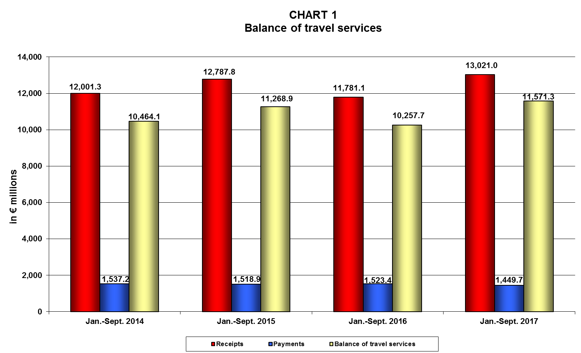
Note: Percentage changes may not add up due to rounding.
* These figures include cruise data collected from sources other than the Border Survey “non-BS cruise data”. For these data, a breakdown by country of origin is not yet available.

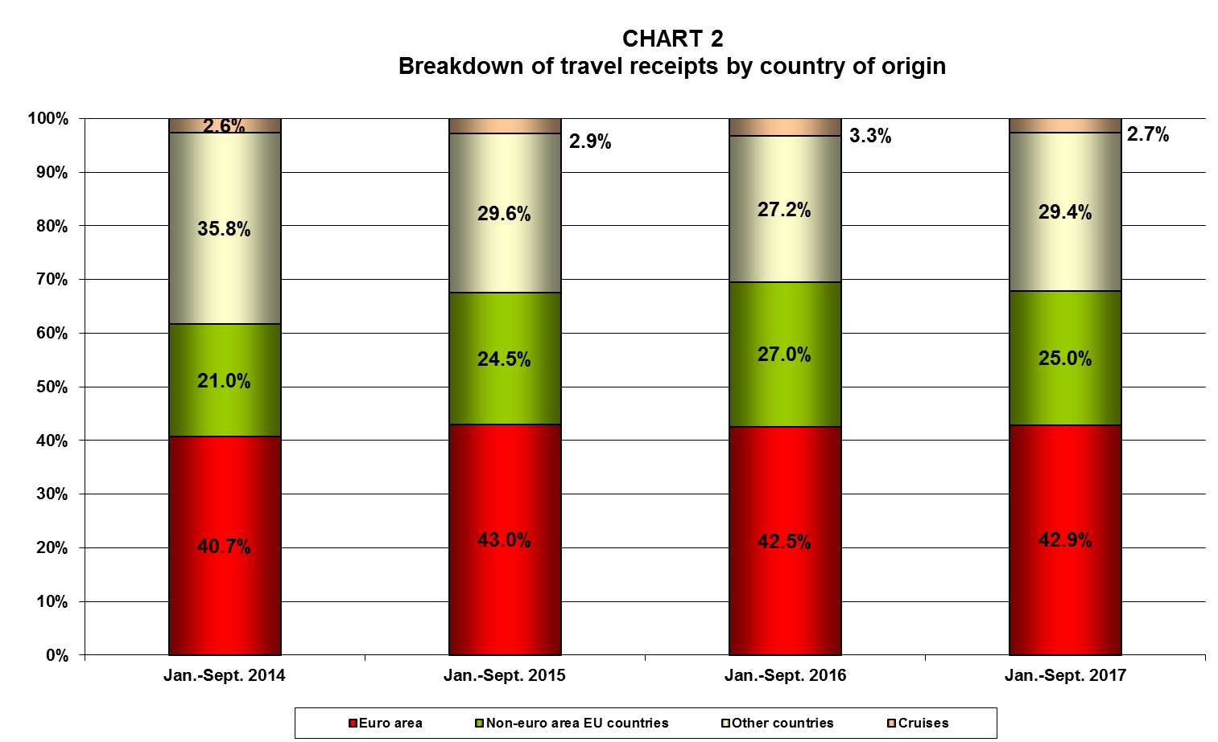

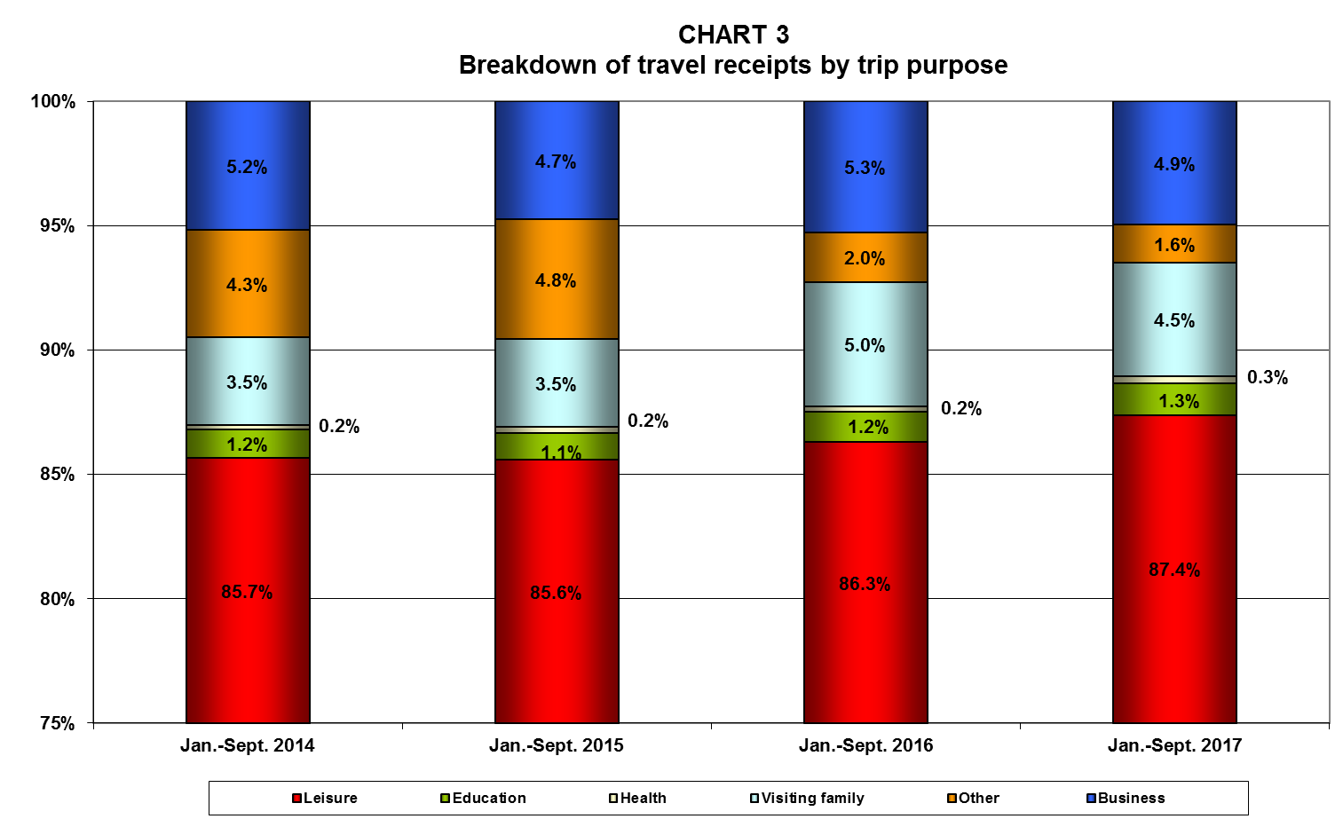
* These figures include cruise data collected from sources other than the Border Survey “non-BS cruise data”. For these data, a breakdown by country of origin is not yet available.
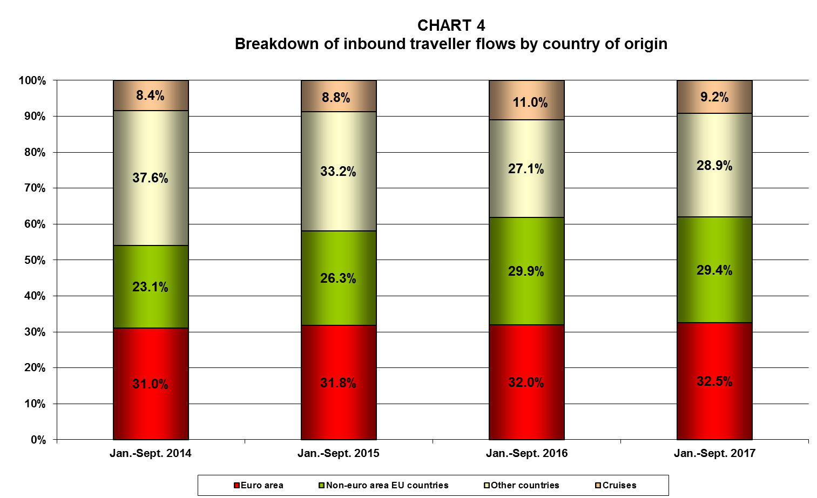
* These figures include cruise data collected from sources other than the Border Survey “non-BS cruise data”. For these data, a breakdown by country of origin is not yet available.
Note: Each same-day visit, irrespective of duration, is assigned one overnight stay.
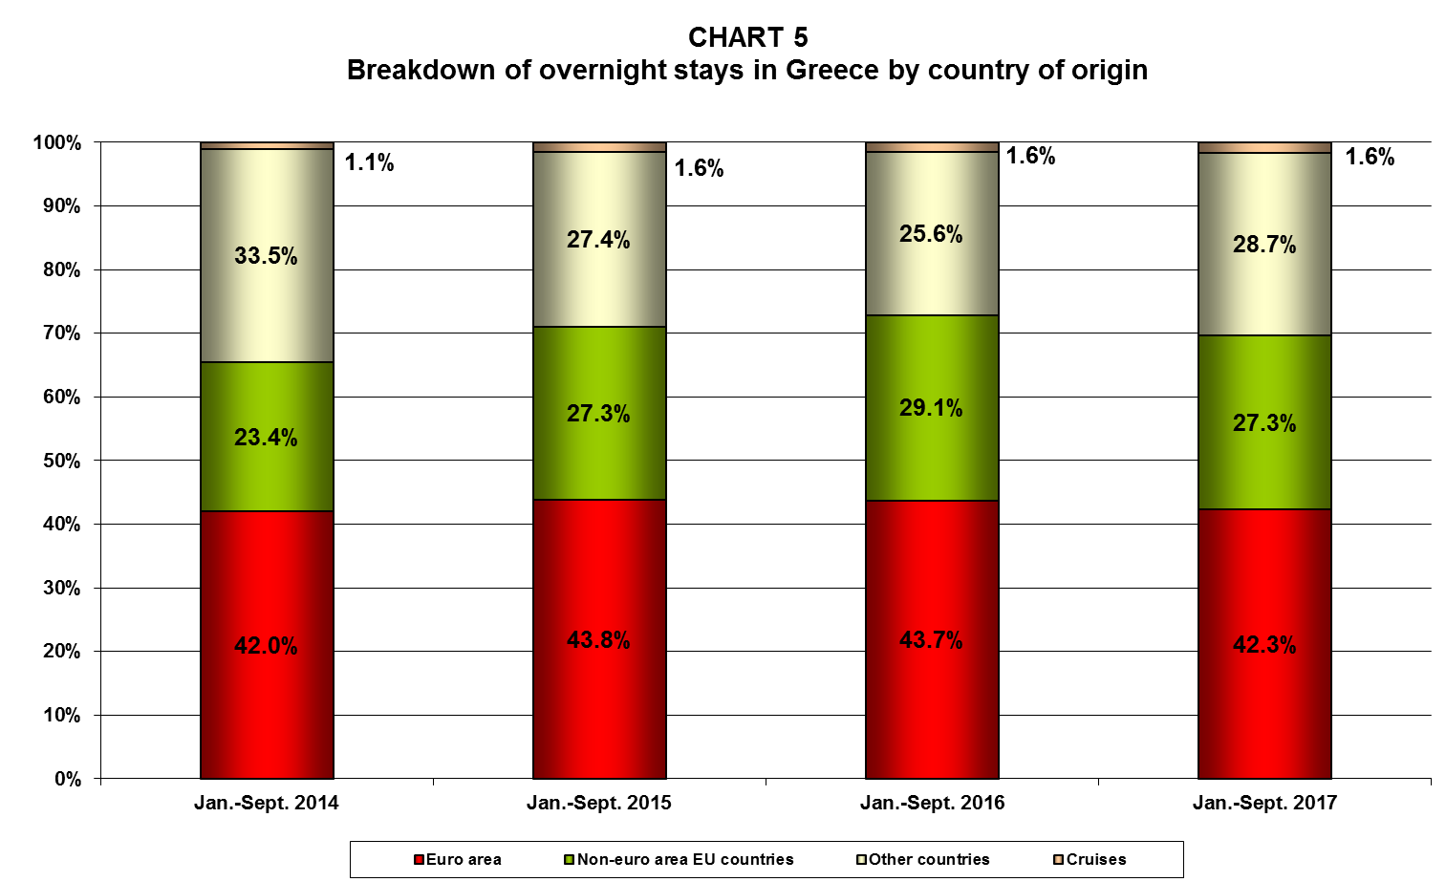

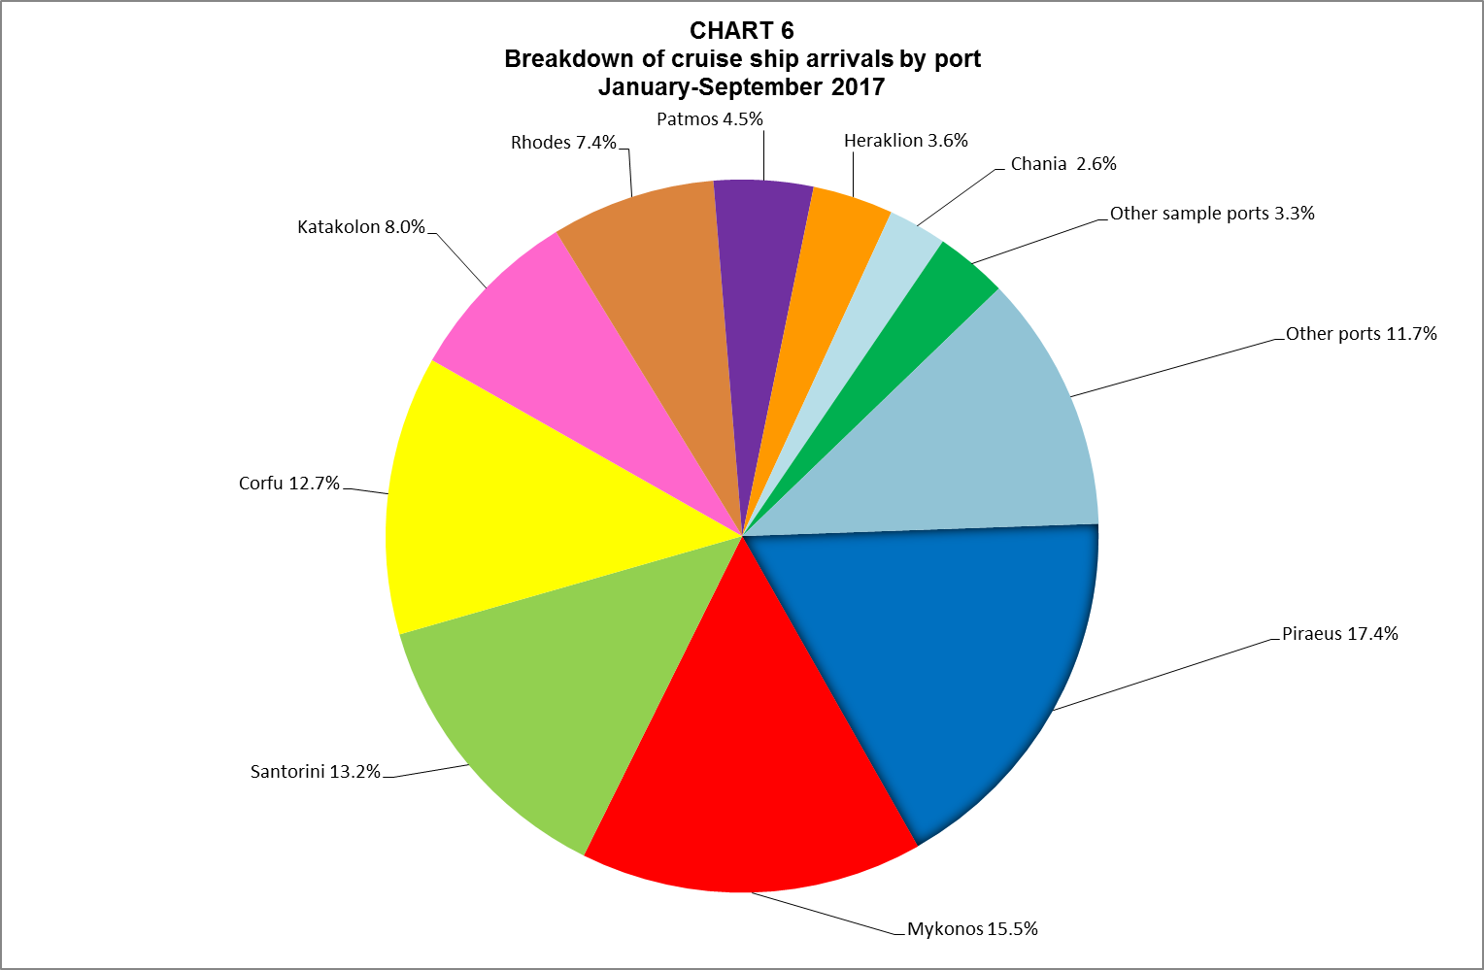

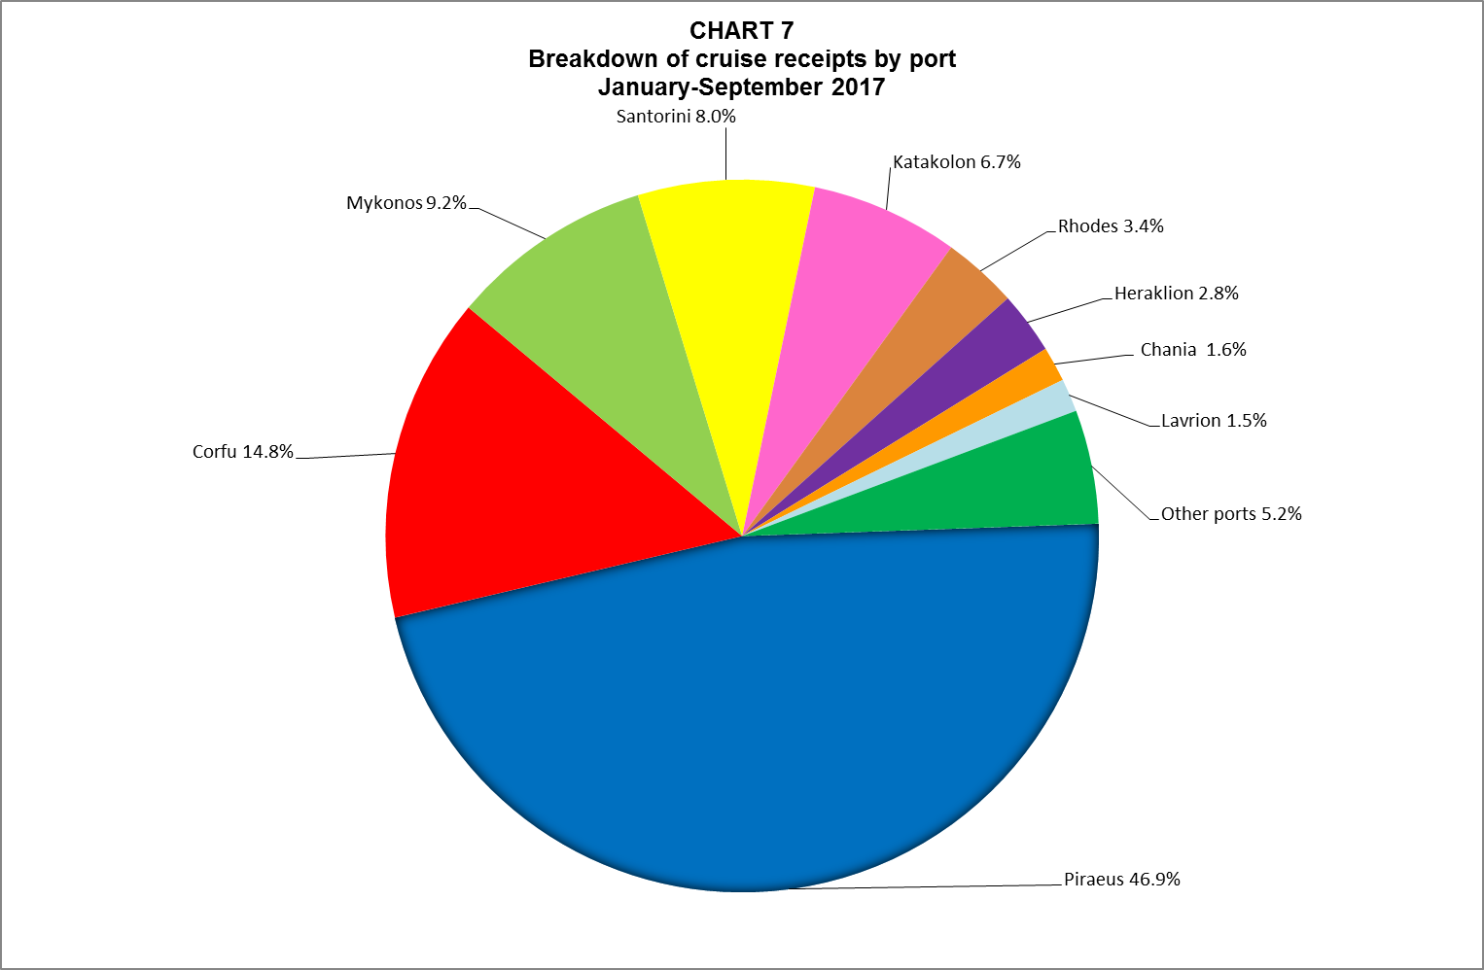

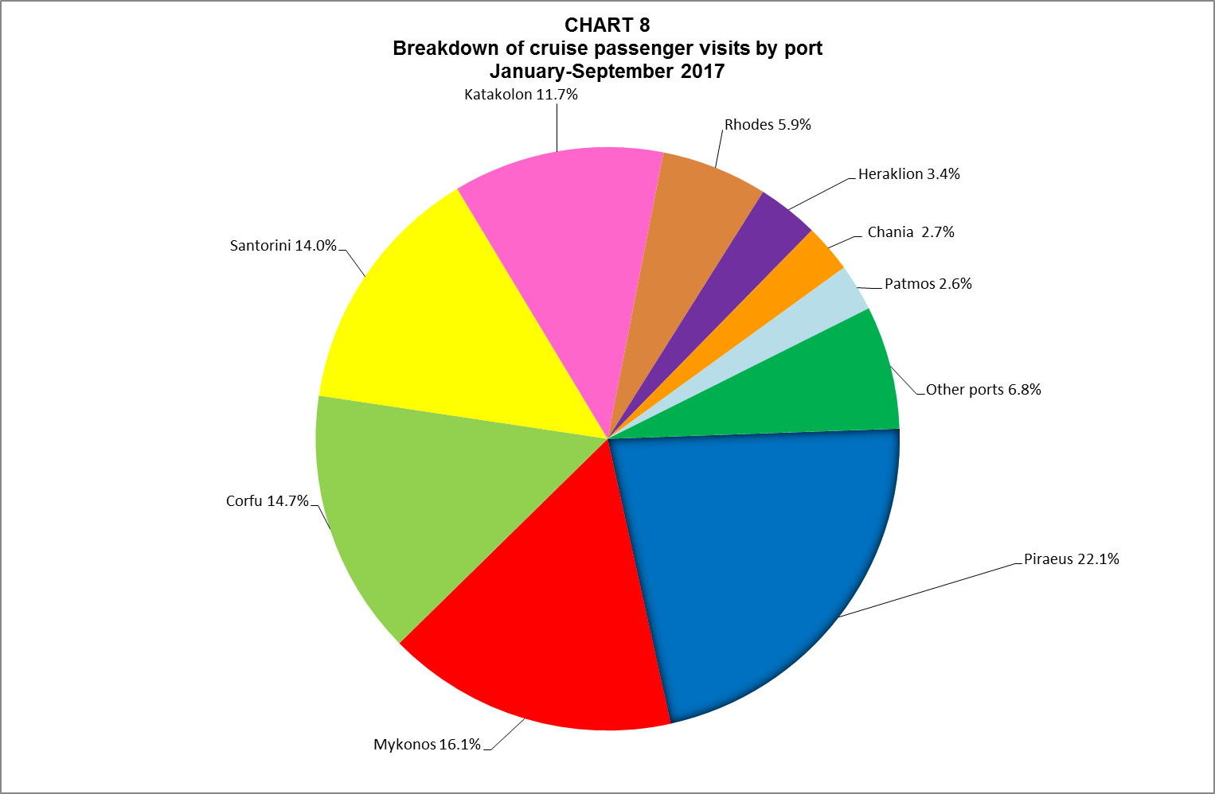

¹ These figures do not include cruise data collected from sources other than the Border Survey.
² Regions are listed according to the official classification under the Nomenclature of territorial units for statistics – NUTS 2013/EU-28 (NUTS 2).
³ The table shows the number of visits (not visitors), since travellers may visit more than one region in the course of one trip.

