

Macroeconomic Management in an Environment of Aggregate Supply Shocks – Lessons from Recent Experience

Background Paper to Speech by Nicholas C. Garganas at the SEANZA Symposium, Bank Negara Malaysia, 25 November 2006

The issue that this background paper addresses concerns macroeconomic management in the face of supply side shocks. While the main focus is on monetary policy reactions the paper will also touch briefly on the possible roles of other policy responses, as well as issues related to the policy mix.
Supply-side shocks have played an important role in shaping the economic history of the global economy over the last 40 years or so. The most common supply-side shock, familiar to both economists and non-economists alike, has been that associated with variations in the price of oil. However, other examples include shocks to total factor productivity, arising from innovation and/or technical progress. A recent example of this type of shock is the technology boom of the late 1990s in the US, leading to the creation of the so-called ‘new economy’.

Some theoretical considerations
Supply-side shocks affect production and, therefore, both potential and actual outputs. Consider, first, the effect on potential output. A negative supply shock (eg an increase in the price of oil or a slowdown in productivity) reduces the potential output of an economy for given levels of inputs and the price level. Alternatively, it increases prices for a given level of output. As production costs rise, profit margins are squeezed and, in an attempt to maintain mark-ups, firms raise their prices. For a given level of demand, therefore, the negative supply shock leads to a fall in output and there will be upward pressure on the price level.
If the upward pressure on the price level is not accommodated by the monetary authority, it will lead to negative demand effects, causing actual output to fall. Moreover, supply-side shocks may induce additional demand effects if, as is likely, consumers and investors are forward looking. These demand effects will be larger the more permanent the shock is deemed to be. A permanent fall in potential output is likely to generate pessimistic expectations of future income and wealth, causing consumers to cut back on expenditures. The decline in the real rate of return on investment will lead firms to invest less. This effect might be particularly strong in the case of a negative supply shock that arises from a slowdown in the rate of technological progress. Additionally, firms may feel the effect of increased financial constraints as falling profits reduce the amount of funds that can be generated internally.
Thus, negative supply-side shocks can cause declines in both potential output and actual output. That growth will slow or, perhaps, turn negative, other things being equal, is not in doubt. What is less clear is what the ultimate effect will be on the price level (or, more generally, inflation). Initially the difference between actual output and potential output, the output gap, is likely to be positive, generating inflationary pressures. However, once the demand effects begin to bite, the output gap will narrow and inflationary pressures subside.
At this point, it is perhaps worth noting that the impact on prices or inflation may differ depending on the source of the negative supply shock. In the case of an oil price shock, the impact on inflation is likely to be greater than other shocks. Aside from being an important input to the production process, oil is also a consumption good and hence its price feeds directly into consumer prices. Prices may also increase to the extent that workers resist the erosion of their real wages by seeking higher nominal wages that must be reflected in the prices of goods and services they produce. This behaviour generates a second round of price increases, resulting possibly in a wage-price spiral. Wage-price spirals are a special concern to policy makers since they are likely to amplify the initial impact of an oil (or any other) price increase. The timing of such second round effects depends crucially on such factors as the average duration of the wage contract and the inclusion of “escalator clauses” in contracts. Evidence from the US and Europe suggests that this time lag is around one year in those currency areas.
The above analysis leads to the conclusion that policy makers face a particularly difficult challenge when dealing with supply-side shocks, unlike demand shocks, which influence both growth and inflation in the same direction, thereby simplifying somewhat the policy response. A negative supply shock tends to reduce growth (perhaps even causing it to become negative), while increasing inflation. Thus monetary policy faces a trade-off; if the authorities seek to maintain real economic activity, they will risk setting off an inflationary spiral.
An important consideration when deciding on the policy response is whether the shock is expected to be permanent or temporary. A temporary shock is unlikely to warrant a policy response provided consumers, investors and policy makers recognise that the shock will be short-lived. In the case of a temporary shock, an imminent recovery will be expected so that the additional demand effects are unlikely to materialise; at the same time any fall in potential output will be temporary. In these circumstances, a response from monetary policy would be inappropriate. The impact of the shock may well have dissipated by the time that the impact of the monetary policy actions is felt. In other words, the long lags associated with monetary policy make it unsuited for fine-tuning the economy to smooth the effect of temporary shocks.
By contrast, a permanent supply-side shock will lead, at least in the short run under conditions of inflexible wages and prices, to the challenge identified above – that is, dealing with lower growth and, most likely, higher inflation. The response of the monetary authorities will depend on their goals. One possible policy framework, although not the one followed by the ECB, is a Taylor rule under which specific weights are assigned to both inflation and growth in formulating monetary policy. One could imagine a situation whereby the interest rate remains essentially unchanged in the short run – the rise in the rate necessitated by the increase in inflation being exactly offset by the reduction necessitated by the fall in growth. In practice, however, it is more likely that the interest rate will rise, given the emphasis most central banks place on price stability in the medium term. A rise in the policy rate also has the advantage that it might keep the lid on possible second round effects if the source of the shock is an oil price rise. What is crucial here is the focus on price stability in the face of shocks. By maintaining price stability, central banks can help ensure that actual output returns to its potential level without the distorting price signals provided by rising inflation.
In the long run, though, a permanent negative supply shock will lead to a reduction in the equilibrium interest rate. In such a situation, monetary policy will concentrate on the need to bring the market rate back into line with the equilibrium rate.
Implicit in the preceding argument is that the policy maker can clearly identify both the nature of shocks and their impact. In practice, however, things are not nearly so clear-cut. The problems associated with measuring potential output, and hence the output gap, are well known and so there is no need to repeat them here. An additional problem is that, even if we have what we consider to be a satisfactory way of measuring potential output, estimates of potential output in real time usually differ from those calculated with historical hindsight (Figure 1). If it is difficult to measure potential output in general, it is even more of a challenge to measure it accurately at the time when the monetary authorities need to make a decision. Moreover, aside from the problems of measuring potential output, there is also the question of whether it is possible to determine whether shocks are temporary or permanent. Clearly, the more quickly a permanent shock can be distinguished from a temporary one, the more quickly it can be determined what, if any, the policy response should be. In practice, this implies a continuous assessment by the monetary authorities of developments on the supply side and, given that an assessment at any particular point in time is likely to be surrounded by considerable uncertainty, the monetary policy response is likely to be gradual.

Experience in the Euro Area and the US with Supply-Side Shocks
The discussion until this point has largely been in an analytical context. One of the basic messages to emerge from the analysis is the fact that theory does not give us a clear lead – there are too many ‘ifs’ and ‘buts’. For this reason, it is useful to examine the recent experience with supply-side shocks and to draw some lessons from this experience.
As Figure 2 shows, the oil price has climbed sharply in the last few years, from under $30 a barrel in 2003 to its high of over $70 a barrel in early August of this year. The factors contributing to this sharp increase stem from both the demand-side and the supply-side. On the demand side, there has been the rapid increase in the energy needs of emerging market economies, especially China and India; on the supply side, there has been low spare capacity throughout the production chain in an environment of geopolitical tensions. Even allowing that the price of oil has recently fallen back to below $60 a barrel, the rise in the price of oil from under $30 a barrel represents a very significant oil price shock. It has come at a time when both the US economy and that of the euro area have been experiencing diverging productivity developments. Since the mid-1990s, the US has experienced a positive productivity shock with the long-term trend in productivity having picked up significantly following two-and-a-half decades of downwardly trending productivity. By contrast, in the euro area, the downward trend that began in the 1970s has continued (Figure 3).
The responses of both the US and the euro area, in terms of inflation and output, to the oil price shock have, until now, been subdued. The US economy has continued to expand at a robust pace. While growth in the third quarter of this year was considerably below expectations, this outcome was primarily a reflection of the slowdown in housing; whilst inflation rose to around 4% this summer, it has subsequently subsided with the Fed’s recent cycle of monetary tightening inter alia having contributed to this outcome. In the euro area, the recovery, while slow in getting under way, is now broadening and deepening. Output this year is growing at close to, if not above, potential. Moreover, inflation, while higher than the “close to but below 2%” definition of price stability set by the ECB, is much below the levels experienced after the first two oil price shocks. These outcomes appear to be more modest than the predictions of econometric models, estimated on the basis of past relationships when oil-price shocks exerted a relatively large impact on inflation and growth. For example, euro area econometric models predict that a 50% increase in oil prices, ceteris paribus, would add almost 0.7 percentage point on average to CPI inflation in the first year, while reducing GDP growth by around 0.4 percentage point (Table 1). We have not, however, seen such large effects this time around. Consequently, other factors appear to have worked to explain the actual outcomes following this particular shock. This argument can be elaborated on.
In the US, the negative supply shock of the rise in oil prices has occurred at a time that the trend growth rate in productivity has been rising, a positive supply shock. Increased labour productivity during the 1990s came from capital deepening; after the burst of the technology bubble at the turn of the millennium, total factor productivity took over as the main engine of labour productivity growth. In addition, it has been argued that Alan Greenspan, having recognised the productivity shock early on (and certainly earlier than many others, including wage earners so that wage pressures remained low), was able to exploit the benefits of the shock in terms of lower inflation and higher output growth by not raising policy rates to the new, higher equilibrium rate implied by the shock in the long run. It has also been pointed out that deregulation of energy markets in the US has made the economy more resilient to oil price shocks since price increases no longer have the same negative effect on productivity that they did in the past.
However, the US experience does not get us very far in understanding that of the euro area. The continued decline in trend labour productivity growth, induced by both a reduction in capital deepening and total factor productivity, implies that the euro area was already experiencing a negative supply-side shock when the oil price rise occurred. This situation suggests that there are factors at work, perhaps in both the US and euro-area economies, which have helped dampen the impact of this latest negative supply side shock. These factors include the following.
First, there is a group of factors that might come under the general heading of structural changes in industrial economies. Some analysts point out that industrial economies are less dependent on oil today than they were during the 1970s (see Figures 4-6). Output is now much less energy-intensive compared to previous decades and other sources of energy have reduced industrial countries’ dependence on oil. However, this cannot be all of the story since if the effect of an oil price rise is proportional to the amount of energy used in production, then, other things being equal, we would still have expected to see a sharp slowdown in economic growth as a consequence of the recent sharp rise in prices. Yet, there has been no such slowing in growth.
A second structural change is the increase in globalisation, which has significantly raised competitive pressures in industrialised countries. Aside from generating a dampening effect on prices in industrialised countries through reduced import prices (a positive supply shock), globalisation has also weakened the power of trade unions. This situation appears to have contributed to subdued second round effects, helping industrial countries avoid wage-price spirals. Employers now resist wage increases in the face of high energy prices in order that their mark-ups are not squeezed. Moreover, international competition has reduced the pricing power of firms substantially, making companies more reluctant to increase their prices than was the case after previous oil prices increases.
In addition to these changes to economic structures, a major factor in containing the effects of negative supply shocks is the enhanced credibility of the monetary authorities – what we might call changing institutional structure. Enhanced credibility can be seen as a consequence of the granting of independence to central banks and the fact that many more central banks are now charged explicitly with, and aim to achieve, the goal of price stability. The two major negative supply shocks of the 1970s and the differing monetary policy reactions to them can be considered to have been decisive in changing attitudes towards monetary policy. This experience, in turn, led to the institutional changes just mentioned.
The oil price rises of 1973-74 and 1979-80 were both accompanied by increases in inflation and declines in output in most industrial countries. However, the monetary policy reaction to the shocks differed. By and large, the first oil shock was accommodated, as monetary policy was loosened, in order to offset the negative impact on growth; in contrast, monetary policy was significantly tightened after the second oil-price shock with the main focus of central banks on the containment of inflation. The non-accommodation of the second oil price rise led to a contraction of output in the short run, but contained the inflationary impact of the shock. It can be argued that the contraction in output was larger than it otherwise might have been since monetary policy during the second oil shock had to be tightened sufficiently not only to deal with the second oil shock, but also to counter the inflationary pressures that remained from the first shock. Additionally, the fact that the monetary authorities did not aim to contain inflation during the first oil price shock implied that it was more difficult during the second shock to alter expectations. Central banks thus faced a high cost, in terms of recessions, in their attempt to restore price stability in the 1980s.
A basic conclusion for policy making that emerges from these two episodes is the following: inappropriate policies in the face of negative supply shocks that exacerbate the inflationary consequences of shocks ultimately lead to an economy paying a higher price over the medium run than would be the case if the authorities pursued policies directed toward price stability. Inappropriate policies in the short run make it more difficult for the authorities to stabilise the economy during subsequent shocks. Such a conclusion is confirmed by movements in headline and core inflation after the first and second oil price shocks. Figure 7 shows the reaction after the first oil price shock; figure 8 after the second oil price shock. Core inflation responded much quicker after the second shock; this provides support for the argument that inflationary expectations had become entrenched after the first shock, necessitating a strong dose of monetary tightening.
Another conclusion that emerges from the above discussion concerns the difficulty of conducting policy in a world of uncertainty. Consider some of the changing relationships mentioned above. These include the decline in the energy intensity of production, the increase in global competition, including its effects on wage behaviour and profit margins, and the ascendancy of central-bank credibility. The upshot of these, and other, changes is that the economic world in which we function is the best described by a structure whose parameters are constantly changing, helping to explain why the predictions of the models about the effects of the most-recent oil price shock have been off the mark. The challenge for the monetary official is to operate in a way that does not depend on a fixed economic structure based on historically average coefficients.
These lessons have been enshrined in the new institutional environment of monetary policy-making that spread throughout industrial countries during the 1990s. By recognising the limits of using an activist monetary policy in a world characterised by uncertainty and changing parameter values, monetary authorities focused their attention on what they could deliver — price stability over the medium term. Crucially, that environment gave monetary policy a new credibility and created a regime of low inflation expectations. In such a regime, inflation is less sensitive to oil price increases. In the context of a New-Keynesian Phillips Curve, for example, inflation depends, inter alia, on current expectations of future inflation. If expectations are solidly anchored, then inflation will not increase in response to a negative supply shock because economic agents will not expect a rise in inflation. Therefore, the policy actions of the monetary authorities that aim at price stabilization, as well as the ability of the monetary authorities to communicate their policy commitments effectively to the public, have kept inflation expectations contained and contributed significantly to the muted response of inflation to this oil shock.
In addition to not leading to a surge in inflation, the recent oil price shock has not led to the kind of recession experienced during the previous oil shocks. In part, this outcome may have something to do with the fact that the recent oil shock reflects, in part, buoyant demand for oil in the US, China and India. Consequently, the deterioration of the terms-of-trade in oil importing countries, appears to have been counterbalanced by higher demand for their goods from the countries that demand more energy.
However, again, the monetary policy framework and increased credibility of monetary policy help explain the more muted output response. Central banks may face less of a trade off between output and inflation. Because the dynamics of inflation are strongly affected by inflation expectations, a credible central bank has the ability to contain inflation without substantially reducing output, since the knowledge that action will be taken if necessary may itself be sufficient. Indeed, evidence indicates that monetary policy effectiveness is the driving force behind improved macroeconomic performance, as measured by the reduction of inflation and output volatility (Figure 9). Underlying this increased effectiveness lies central bank independence and greater transparency which gives monetary authorities the chance to communicate their monetary policy objectives more effectively.
The ECB’s two-pillar monetary policy framework, which takes account of real, monetary and financial factors, provides conditions under which credibility is attained, allowing the euro area to reap the benefits just discussed. The explicit goal of maintaining price stability, along with an actual quantitative definition of stability as an inflation rate below but close to 2%, helps anchor inflationary expectations. Figure 10 shows how inflationary expectations have been anchored since the creation of the euro area and the ECB. In spite of the slight rise in expected inflation since the early years of economic and monetary union, expectations remain anchored around 2%. At the same time, new information relevant for monetary policy formulation is assessed in Governing Council meetings using the two pillars – the economic and monetary analysis. The economic analysis focuses on real activity and financial conditions, factors that influence price developments in the medium term. The monetary analysis provides a longer-term perspective based on the fact that inflation is ultimately in the long run a monetary phenomenon. Overall, the strategy does not justify short-term activism and efforts to “fine-tune” the economy.
The existence of an explicit goal, in combination with the current framework for monetary policy-making, has been successful in enabling the ECB to establish credibility during its short history. The ECB’s institutional structure also facilitates transparent policy-making and the communication of policy decisions to the general public and financial markets. That this communication has been successful is supported by some evidence suggesting that the ECB’s focus on a quantitative definition of price stability has influenced price and wage setters in the euro area. Although prices tend to move very sluggishly in the euro area compared to, say, the US, inflationary shocks dissipate at a similar rate to the US – the extra rigidity in the euro area is offset by the benefits of the effectiveness of monetary policy in anchoring euro area inflationary expectations.
So what does the foregoing analysis imply for policy prescriptions now? As inflation expectations appear to be appropriately anchored, it may be tempting for policy-makers to follow an accommodative monetary policy, riding the back of increased credibility. However, an accommodative monetary policy would not be a prudent prescription since the inflation expectations of economic agents may rise, ending the period of low inflation expectations. Indeed, if inflation expectations depend not only on current inflation, but also on average inflation in an earlier, higher inflation, regime, a large and persistent shock, such as a negative energy supply shock may well lead economic agents to raise their expectations that the monetary authority will shift to a higher inflation regime.
The credibility that monetary authorities have gained so far must not be jeopardized by loosening the tolerable inflation range. A credible central bank can help stabilize the economy during this oil shock without moving to a higher inflation target. Indeed, the credible central bank can take advantage of its credibility during an oil price shock because it faces less of a trade off between inflation and output than a less credible central bank. This situation enables the credible central bank to counter the shock through a smaller tightening of monetary policy than would otherwise be the case because the dynamics of inflation due to expectations are self-contained. In the specific case of the ECB, credibility and well-anchored inflationary expectations have allowed monetary policy to be quite accommodating despite actual inflation at or above 2% for more than two years. More recently, however, there have been potential upside risks to inflation stemming from both real economic and monetary developments. As a consequence, the ECB has acted to preempt any unfolding of these upside risks by withdrawing monetary accommodation. This circumstance underlies the rising rates in the euro area during the past year.

A Potential Role for Other Economic Policies?
So far attention has concentrated on monetary policy responses to supply shocks. Before concluding, it is useful to make a few remarks on the potential role for other economic policies.
First, an economy’s tolerance of negative supply shocks will be enhanced if labour market flexibility is increased. This fact is something that is widely recognised and, in the EU, it has resulted in the adoption of various policies designed to reduce rigidities within the framework of the Lisbon Agreement. In the absence of central bank credibility, a monetary policy response to a negative supply shock is especially necessary because of the sluggish response of real wages to the shock. Negative supply side shocks increase marginal costs (either directly in the case of an oil price shock or through the need to employ more labour to produce the same output in the case of the negative productivity shock). Inflation in these contexts is the result of a lack of adjustment of real wages. Thus the more quickly real wages adjust, the more quickly actual output will converge to the new potential output. If economies were more flexible, then the challenge for monetary policy posed by a negative supply shock would be much reduced.
Second, if monetary policy is focused on price stability and anchoring inflationary expectations, the potential recessionary effects of a negative supply-side shock could be countered through fiscal policy. If fiscal conditions give governments the flexibility to let automatic stabilisers work following a negative supply shock, tax revenues will fall and transfers increase, stimulating the economy. Moreover, a tight monetary policy that aims at countering the inflationary consequences of an adverse supply shock could be accompanied by a discretionary fiscal expansion, i.e. a reduction in tax rates or an increase in government spending. The latter policies might further contain the recessionary impact of the shock by offsetting the negative effect of the oil price rise on private demand. Therefore, if government has the necessary flexibility, fiscal policy could lessen the stabilization burden of monetary policy.
In the euro area, however, the scope for fiscal policy is, at present, limited because of the failure to tighten fiscal policy, during previous years when output was above trend. As a result, many countries have been left with significant fiscal deficits and high debt levels. Even the room for automatic stabilizers to work, while staying within the rules of the Stability and Growth Pact, is extremely limited. This situation highlights the need for governments to undertake the fiscal reforms necessary to generate a fiscal balance or surplus over the economic cycle. Only in this way can fiscal policy be available as a tool to counter the impact of any future negative supply shocks.

Conclusions
To conclude, the message of this paper is that central banks should not respond to negative supply shocks by loosening monetary policy. To do so would simply undermine the credibility that many central banks have worked to acquire and increase the costs of restraining inflation in the future. Rather central banks can exploit the credibility earned in the past – monetary policy is more effective with well-anchored expectations and this enables central banks to counter inflationary shocks at less cost.
At the same time, other policies such as fiscal and, more importantly, structural have a significant role. We should not, after all, forget the classic lesson of Jan Tinbergen that there need to be just as many instruments as there are targets. Monetary policy cannot do everything and it is far better that it remains focused on what it is capable of achieving, namely price stability. In this way, it provides the conditions necessary to achieve other macroeconomic goals, including economic growth and employment creation.

Bibliography

Andersen, P.S. and Bernard, H. J., 1991. Energy Shocks and the Demand for Energy. BIS Working Paper No. 17.
Bernanke, B.S., Gertler, M., Watson, M., 1997. Systematic Monetary Policy and the Effects of Oil Price Shocks. Brookings Papers on Economic Activity, 91-116.
Bernanke, B. S., Gertler, M. and Watson, M. 2004. Oil Shocks and Aggregate Macroeconomic Behaviour: the role of monetary policy, Journal of Money, Credit and Banking, 36, 2.
Blanchard, O. and Gali, J. 2005. Real Wage Rigidities and the New Keynensian Model. NBER Working Paper No. 2005.
Blinder, A. S. and Reis, R., 2005. Understanding the Greenspan Standard. Federal Reserve of Kansas City, Symposium on ‘The Greenspan Era: Lessons for the Future’.
Carlstrom, C. and Fuerst, T. 2005. Oil Prices, Monetary Policy and the Macroeconomy, Policy Discussion Paper No.10, Federal Reserve Bank of Cleveland.
Cecchetti, S. G., Flores-Lagunes, A., Krause, S., 2004. Has Monetary Policy Become More Efficient? NBER Working Papers 10973.
Dhawan, R., and Jeske K., 2006. How Resilient is the Modern Economy to Energy Price Shocks? Federal Reserve Bank of Atlanta Economic Review, 91, 3, 21-32.
Dotsey, M., Reid, M., 1992. Oil Shocks, Monetary Policy, and Economic Activity, Federal Reserve Bank of Richmond Economic Review, July/August, 14-27.
ECB, 2004. Oil Prices and the Euro Area Economy, Monthly Bulletin of European Central Bank, November.
ECB, 2006a. Effects of the Rising Trade Integration of Low-Cost Countries on Euro Area Import Prices, Monthly Bulletin of European Central Bank, August, 56-7.
ECB, 2006b. Monetary Policy Activism, Monthly Bulletin of European Central Bank, November, 67-81.
Edge, R. M., Laubach, T., Williams, J.C, 2003. The Responses of Wages and Prices to Technology Shocks. Mimeo.
Gagnon, J.E., 1997. Inflation Regimes and Inflation Expectations. United States Department of the Treasury Research Discussion Paper 9701.
Gali, J., Lopez-Salido, J.D., Valles J., 2003. Technology Shocks and Monetary Policy: Assessing the Fed’s Performance. Journal of Monetary Economics, 50, 723-743.
Gerdesmeier, D., and Roffia, B., 2004. Taylor Rules for the Euro Area: The Issue of Real-Time Data. Deutsche Bundesbank Discussion Paper, No. 37.
Gramlich E. M., 2004. Oil shocks and Monetary Policy. Remarks at the Annual Economic Luncheon, Federal Reserve Bank of Kansas.
Hamilton, J. and Herrera, A., 2004. Oil Shocks and Aggregate Behavior: the role of monetary policy, Journal of Money, Credit and Banking, 36, 2.
Hooker, M.A., 2002. Are Oil Shocks Inflationary? Asymmetric and Nonlinear Specifications versus Changes in Regime. Journal of Money Credit and Banking, 34, 540-561.
Hunt, B., 2005. Oil Price Shocks: Can they Account for the Stagflation of the 1970s? IMF Working Paper, No 215.
Hutchison, M.M., 1991. Aggregate Demand, Uncertainty and Oil Prices: The 1990 Oil Shock in Comparative Perspective. BIS Economic Papers 31.
Jones, D. W., Leiby, P. N. and Paik, I. K., 2004. Oil Price Shocks and the Macroeconomy: what have we learned since 1996? The Energy Journal, 25, 2.
King, M., 2006. Monetary Policy Developments. Speech at a dinner hosted by the Scottish Financial Enterprise and the Edinburgh Chamber of Commerce.
Liikanen, E., 2006. Monetary Policy in Theory and Practice. Speech at the Turku School Economics Business Administration.
Meyer, L. H., 2000. The Economic Outlook and the Challenges Facing Monetary Policy. Speech at the Toronto Association for Business and Economics.
OECD, 2006. Globalisation and Inflation in the OECD Economies, Working Party No. 1 on Macroeconomic and Structural Policy Analysis, ECO/CPE/WP1(2006)14.
Orphanides, A. and van Norden, S., 2002. The Unreliability of Output Gap Estimates in Real Time. Review of Economic and Statistics, 84, 569-583.
Parry, R.T., 2000. Monetary Policy in the New Environment: The US Experience. Federal Reserve Bank of San Francisco Economic Letter, 2000-31.
Skoczylas, L. and Tissot, B., 2005. Revisiting Recent Productivity Developments Across OECD Countries, BIS Working Papers, no. 182.
Smets, F. and Wouters, W., 2002. An Estimated Stochastic Dynamic General Equilibrium Model of the Euro Area. ECB Working Paper No. 171.
Taylor, J.B. 1999. Staggered Price and Wage Setting in Macroeconomics. In Taylor J. B. And M. Woodford (eds), Handbook of Macroeconomics, Volume 1, 1009-1050.
Trehan, B., 2005. Oil Price Shocks and Inflation. Federal Reserve Bank of San Francisco Economic Letter, 2005-28.
Weber, A. A., 2006. Oil Price Shocks and Monetary Policy in the Euro Area. Whitaker Lecture before the Central Bank and Financial Services Authority of Ireland.
Woodford, M, 2003. Interest and Prices. Foundation of a Theory of Monetary Economics. Princeton University Press.
Yellen, J. L., 2005. Productivity and Inflation. Federal Reserve Bank of San Francisco Economic Letter, 2005-04.
Yellen, J. L., 2006. Enhancing Fed Credibility. Federal Reserve Bank of San Francisco Economic Letter, 2006-05.

Table 1: Impact of a 50% increase in oil prices on euro area inflation and GDP growth

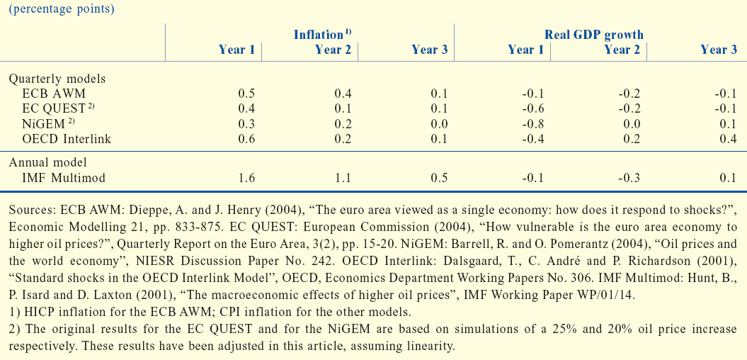
Source: ECB (2004).
Figure 1: Potential Output: real time and latest estimates compared
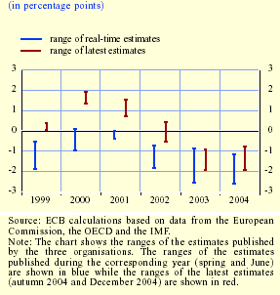

Source: ECB, 2005. Monthly Bulletin, February, Box 5
Source: Thompson Financial, Datastream
Figure 3: Labour productivity in the US and the Euro Area
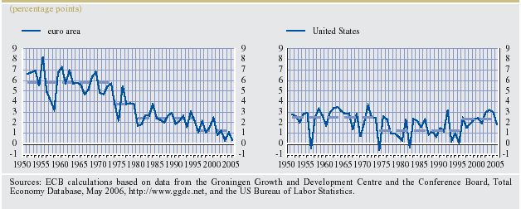
Source: Source: R Gomez-Salvador, A Musso, M Stocker and J Turunen, 2006. Labour Productivity Developments in the Euro Area, ECB Occasional Paper, no. 53.

Figure 4: Oil dependency in the Euro Area (1971 and 2000 compared)

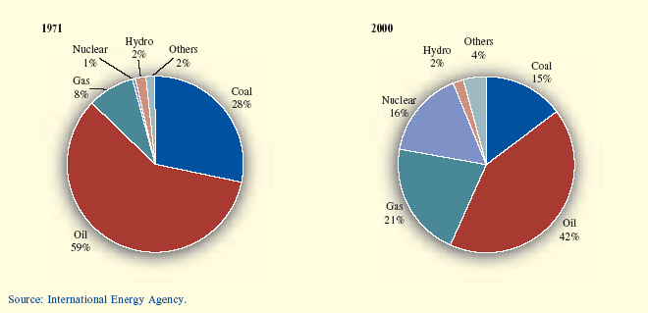

Figure 5: Oil Dependency in the US: 1971 and 2000 compared

Source: Energy Information Administration

Figure 6: Oil Input to Production

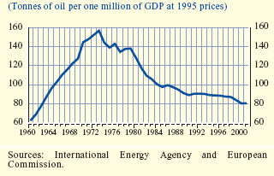
Figure 7: German Headline and Core Inflation during First Oil Price Shock
Figure 8: German Headline and Core Inflation during Second Oil Price shock
Figure 9: Changes in Performance due to Policy

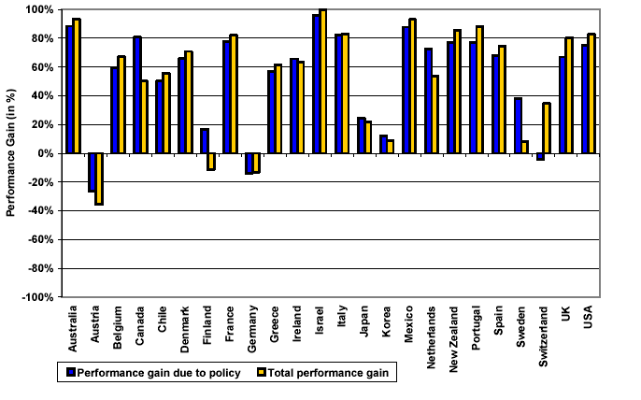
Source: Cecchetti et al (2004), Figure 4.

Endnotes ? Taylor (1999) provides direct evidence for the US; evidence for Europe is indirect, but suggests that the duration of wage contracts is around one year as, in the US (see Smets and Wouters, 2002).
The literature suggests that policy recommendations using real time data may differ substantially from those based on ex post revised data (see, for example, Orphanides and van Norden, 2002 and Gerdesmeier and Roffia, 2004). For instance, the inflation pressures in the US that accompanied the 1970s oil price shocks can partly be attributed to the monetary authorities’ misperception of the output gap (on the basis of real time data, potential output was overestimated) and this led to an easier monetary policy than might otherwise have been followed (see Hunt, 2005).
On developments in both labour productivity and total factor productivity since 1960, see also Skozlas and Tissot (2005).
On the impact of oil price rises on the US economy, see Bernanke et al (1997), and the exchange with Hamilton and Herrera (Hamilton and Herrera, 2004; Bernanke et al, 2004), Carlstrom and Fuentes (2005) and Jones et al (2004). The Federal Reserve Bank of San Francisco (2005) refers to evidence that suggests that, following a 50% rise in oil prices, output in the US two years hence will have fallen some 0.4 percentage point below steady state and inflation will have risen by 0.2 percentage point.
ECB (2006b), p.76.
See Blinder and Reis, 2005.
Dwahan and Jeske, 2006. The mechanism through which this works is as follows. In the early 1970s, energy prices in the US were still controlled. Hence, following the first oil price shock energy was rationed and it was not necessarily the case that the most productive units were those that got access to the energy available. Thus oil price shocks led to negative effects on productivity.
ECB (2006b), p.76.
Andersen and Bernard, 1991.
Dhawan and Jeske, 2006.
This factor has been noted by Weber (2006), King (2006) and Liikanen (2006). The OECD (2006) calculates that, in the absence of the effects of globalisation, inflation in the advanced countries taken together would have been around 0.3 percentage point higher over the period 2000-2005. See also ECB (2006a).
Even if monetary policy was tightened eventually in the aftermath of the first oil shock in Germany and the US, it was relaxed at the time of the shock.
See Yellen, 2006.
Woodford (2003).
Cecchetti and Krause (2004) provide evidence supporting this view. Their results are based on the estimation of monetary policy efficiency frontiers, which are defined in terms of inflation and output volatility. One may, of course, argue that it is not the effectiveness of monetary policy that explains the better macroeconomic performance but rather the fact that there has been a reduction in the variability of supply shocks. The authors divide the change in performance into the proportion accounted for by the improvement in policy effectiveness and the proportion that is due to changes in the variability of shocks. They find that for the majority of the 24 countries analyzed over the 1980s and 1990s, more effective policies underlie the improvement in overall macroeconomic performance.
ECB (2006b), p.79.
See Gagnon, 1997.
The idea underlying this argument is provided by Woodford (2003). Current inflation is a function of marginal cost (including changes in oil prices) and inflation expectations. If inflation expectations are well anchored they need not impact on current inflation during an oil price shock because market participants know that the central bank will take action to stabilize inflation. Hence, the amount of actual monetary tightening will be less than that required by a less credible central bank because inflation will not have its own internal dynamic resulting from less-than-well anchored expectations.
See Blanchard and Gali (2005).

