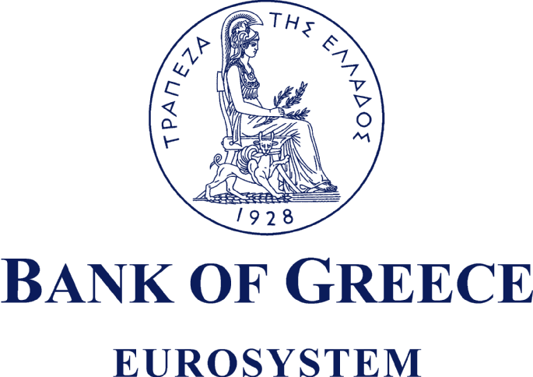

STATEMENT OF COMMITMENT TO THE FX GLOBAL CODE

Bank of Greece has reviewed the content of the FX Global Code (“Code”) and acknowledges that the Code represents a set of principles generally recognised as good practice in the wholesale foreign exchange market (“FX Market”). The Institution confirms that it acts as a Market Participant as defined by the Code, and is committed to conducting its FX Market activities (“Activities”) in a manner consistent with the principles of the Code. To this end, the Institution has taken appropriate steps, based on the size and complexity of its Activities, and the nature of its engagement in the FX Market, to align its Activities with the principles of the Code.

Bank of Greece

Athens, 14 May 2018

