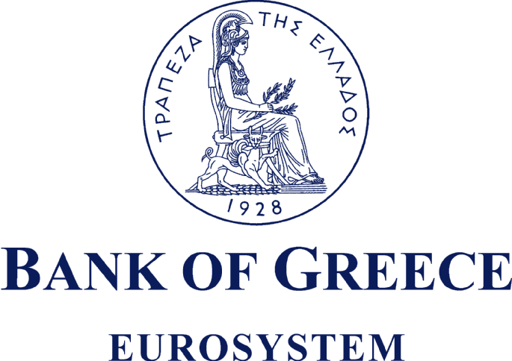

PRESS RELEASE

Athens, 10 November 2006

Subject: Addition of the word «EUROSYSTEM» to the Bank of Greece logo

Pursuant to the decision of the Governing Council of the European Central Bank (ECB) that the word «EUROSYSTEM» be added to the respective logos of the ECB and the national central banks which, together with the ECB, make up the Eurosystem, the General Council of the Bank of Greece approved the change to the Bank of Greece logo used to this day; the new logo shall henceforth be composed in its Greek and English versions as follows:

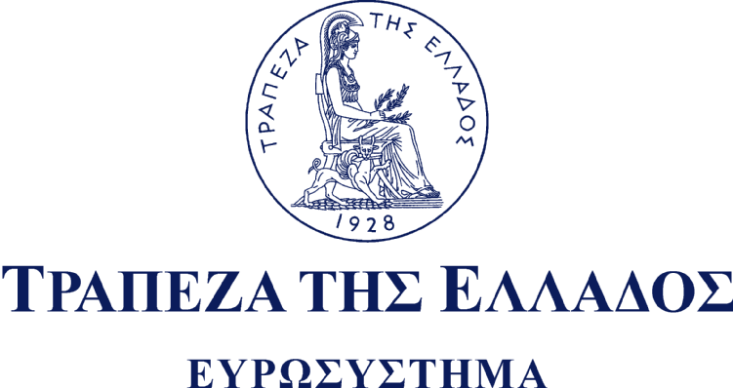

It is to be noted that the Bank of Greece emblem, adopted at the time of the institution’s foundation in 1928, was designed by Michael Axelos and sculpted in bas-relief by Ioannis Kanakis. In the words of the 1928 decision, it depicts «Athena, in profile, seated on an archaic throne and facing right, wearing the crested Attic helmet and holding an olive branch, symbol of peace, in her right hand. By her side, stands the mythical griffin».

