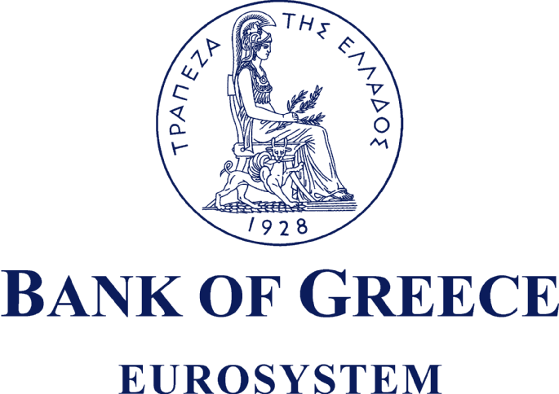

Payment and Settlement Systems Department

Electronic Secondary Securities Market (HDAT)

Announcement

Following the decision of the Minister of Finance, Government Gazette B’ 1617/31.7.2015, and the decision of the HDAT Management Council N. 72/3.8.2015, HDAT shall re-open today, Monday August 3, 2015.