**2025 NUMISMATIC PRODUCTS RELEASES**

1. Sale of a €10 Silver Collector Coin dedicated to:

“**200 YEARS FROM THE DEATH OF LASKARINA BOUBOULINA**”.

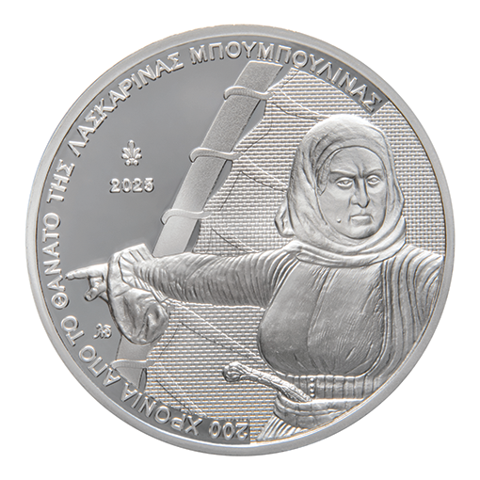

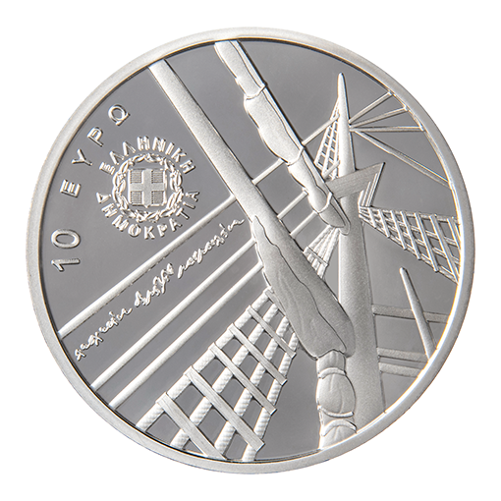

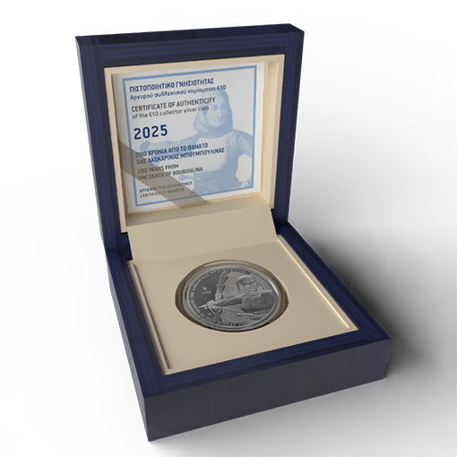

The coin will be released on **27 March 2025** and the selling price is €90 (VAT included).

The maximum coin issue is 1,500 coins.

During the period from **27/03/2025 to 15/04/2025,** a limit of one (1) piece per buyer applies. After that period, there will be no quantity restrictions. Purchase of larger quantities (by official coin merchants only) is subject to approval in writing by the 25th Directorate of the General Accounting Office of State.

1. Sale of a €10 Silver Collector Coin dedicated to:

“**PHILHELLENES –SANTORRE DI SANTAROSA**”.

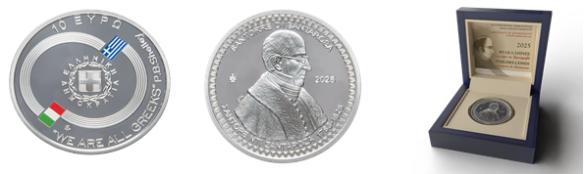

The coin will be released on **27 March 2025** and the selling price is €90 (VAT included).

The maximum coin issue is 1,000 coins.

During the period from **27/03/2025 to 15/04/2025,** a limit of one (1) piece per buyer applies. After that period, there will be no quantity restrictions. Purchase of larger quantities (by official coin merchants only) is subject to approval in writing by the 25th Directorate of the General Accounting Office of State.

1. Sale of a €10 Silver Collector Coin dedicated to:

“**GREEK CULTURE – MATHEMATICIANS – ERATOSTHENES**”.

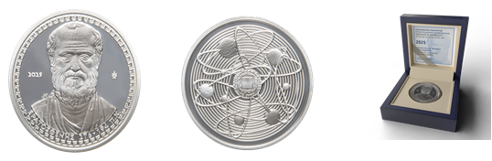

The coin will be released on **29 April 2025** and the selling price is €90 (VAT included).

The maximum coin issue is 2,000 coins.

During the period from **29/04/2025 to 19/05/2025,** a limit of one (1) piece per buyer applies. After that period, there will be no quantity restrictions. Purchase of larger quantities (by official coin merchants only) is subject to approval in writing by the 25th Directorate of the General Accounting Office of State.

1. Sale of a €10 Silver Collector Coin dedicated to:

“**GREEK CULTURE – ANCIENT GREEK TECHNOLOGY – PTOLEMY’S ASTROLABE**”.

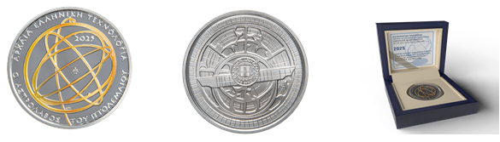

The coin will be released on **29 April 2025** and the selling price is €90 (VAT included).

The maximum coin issue is 2,000 coins.

During the period from **29/04/2025 to 19/05/2025,** a limit of one (1) piece per buyer applies. After that period, there will be no quantity restrictions. Purchase of larger quantities (by official coin merchants only) is subject to approval in writing by the 25th Directorate of the General Accounting Office of State.

1. Sale of a €200 Gold Collector Coin dedicated to:

“**100 YEARS FROM THE BIRTH OF MIKIS THEODORAKIS**”.

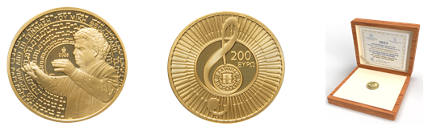

The coin will be released on **20 May 2025** and the selling price is €950 (VAT included).

The maximum coin issue is 750 coins.

During the period from **20/05/2025 to 10/06/2025,** a limit of one (1) piece per buyer applies. After that period, there will be no quantity restrictions. Purchase of larger quantities (by official coin merchants only) is subject to approval in writing by the 25th Directorate of the General Accounting Office of State.

1. Sale of a Blister set containing all eight denominations of 2025 Greek euro coins dedicated to:

“**TOURISM – THESSALY**”.



The set will be released on **5 June 2025** and the selling price is €20 (VAT included).

The maximum set issue is 5,000 sets.

During the period from **05/06/2025 to 25/06/2025,** a limit of one (1) piece per buyer applies. After that period, there will be no quantity restrictions. Purchase of larger quantities (by official coin merchants only) is subject to approval in writing by the 25th Directorate of the General Accounting Office of State.

1. Sale of a €6 Silver Collector Coin dedicated to:

“**INTERNATIONAL YEAR OF GLACIERS’ PRESERVATION**”.

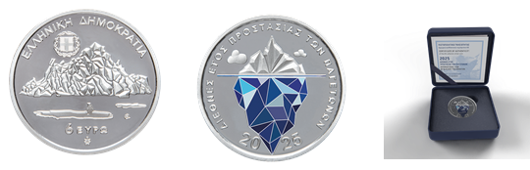

The coin will be released on **23 June 2025** and the selling price is €50 (VAT included).

The maximum coin issue is 1,500 coins.

During the period from **23/06/2025 to 14/07/2025,** a limit of one (1) piece per buyer applies. After that period, there will be no quantity restrictions. Purchase of larger quantities (by official coin merchants only) is subject to approval in writing by the 25th Directorate of the General Accounting Office of State.

1. Sale of a Blister pack with a €5 Silver Collector Coin dedicated to:

**“50 YEARS FROM THE FOUNDATION OF THE WAR MUSEUM”.**

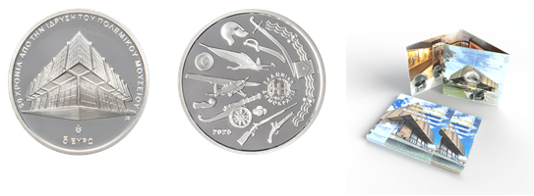

The set will be released on **15 July 2025** and the selling price is €20 (VAT included).

The maximum pack issue is 2,000 packs.

During the period from **15/7/2025 to 4/8/2025,** a limit of one (1) piece per buyer applies. After that period, there will be no quantity restrictions. Purchase of larger quantities (by official coin merchants only) is subject to approval in writing by the 25th Directorate of the General Accounting Office of State.

1. Sale of a €1.5 Collector Coin dedicated to:

“**AESOP’S FABLES – THE CICADA AND THE ANT**”.

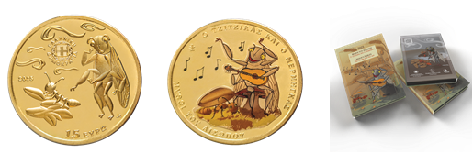

The coin will be released on **30 September 2025** and the selling price is €15 (VAT included).

The maximum coin issue is 3,500 coins.

During the period from **30/9/2025 to 20/10/2025,** a limit of one (1) piece per buyer applies. After that period, there will be no quantity restrictions. Purchase of larger quantities (by official coin merchants only) is subject to approval in writing by the 25th Directorate of the General Accounting Office of State.

1. Sale of a €100 Gold Collector Coin dedicated to:

“**GREEK MYTHOLOGY – THE OLYMPIAN GODS – HESTIA**”.

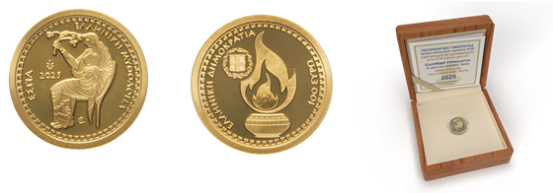

The coin will be released on **13 October 2025** and the selling price is €530 (VAT included).

The maximum coin issue is 1,200 coins.

During the period from **13/10/2025 to 03/11/2025,** a limit of one (1) piece per buyer applies. After that period, there will be no quantity restrictions. Purchase of larger quantities (by official coin merchants only) is subject to approval in writing by the 25th Directorate of the General Accounting Office of State.

1. Sale of a €6 Silver Collector Coin dedicated to:

“**100 YEARS FROM THE BIRTH OF THE SCULPTOR TAKIS**”.

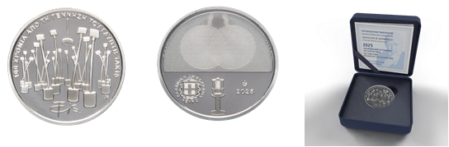

The coin will be released on **23 October 2025** and the selling price is €50 (VAT included).

The maximum coin issue is 1,000 coins.

During the period from **23/10/2025 to 12/11/2025,** a limit of one (1) piece per buyer applies. After that period, there will be no quantity restrictions. Purchase of larger quantities (by official coin merchants only) is subject to approval in writing by the 25th Directorate of the General Accounting Office of State.

1. Sale of a Blister pack with a €5 Silver Collector Coin dedicated to:

**“ENDANGERED FAUNA OF GREECE – THE CINEREOUS VULTURE (AEGYPIUS MONACHUS)”.**

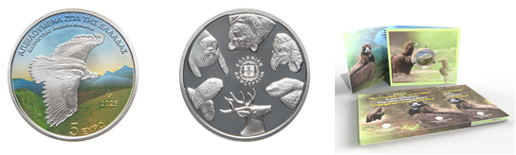

The set will be released on **11 November 2025** and the selling price is €20 (VAT included).

The maximum pack issue is 2,000 packs.

During the period from **11/11/2025 to 01/12/2025,** a limit of one (1) piece per buyer applies. After that period, there will be no quantity restrictions. Purchase of larger quantities (by official coin merchants only) is subject to approval in writing by the 25th Directorate of the General Accounting Office of State.

1. Sale of a €50 Gold Collector Coin dedicated to:

“**CULTURAL HERITAGE – METEORA**”.

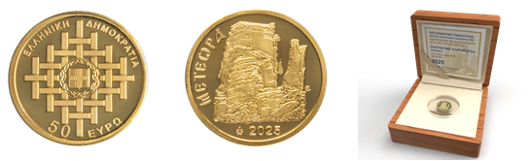

The coin will be released on **3 December 2025** and the selling price is €160 (VAT included).

The maximum coin issue is 1,200 coins.

During the period from **03/12/2025 to 22/12/2025,** a limit of one (1) piece per buyer applies. After that period, there will be no quantity restrictions. Purchase of larger quantities (by official coin merchants only) is subject to approval in writing by the 25th Directorate of the General Accounting Office of State.

1. Sale of a Blister pack with a €5 Silver Collector Coin dedicated to:

**“200 YEARS FROM THE BATTLE OF MANIAKI”.**

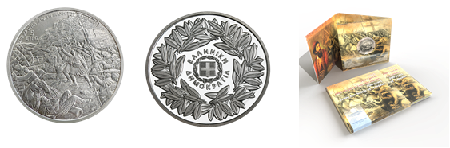

The coin will be released on **3 December 2025** and the selling price is €20 (VAT included).

The maximum coin issue is 2,000 coins.

During the period from **03/12/2025 to 22/12/2025,** a limit of one (1) piece per buyer applies. After that period, there will be no quantity restrictions. Purchase of larger quantities (by official coin merchants only) is subject to approval in writing by the 25th Directorate of the General Accounting Office of State.