Insertion of the AAU BIC or the Direct Debit mandate in the registration form
The registration form allows for the creation of unlimited AAU BICs Or Direct Debit Mandates using a .txt file. For participants with a large number of AAUs or Direct Debit mandates the .txt file will in any case be the preferred option.

CASH ACCOUNT - Authorised Account User
Please note that the .txt file to create the Authorised Account Users must follow the below order and contain the following information:
CashAccountNumber, AuthorisedUserBic, MaximumIPAmount, ParticipationType
The name of the .txt cannot contain spaces (e.g. authorised_ account_user).
Be reminded that the Maximum IP Amount is the maximum amount accepted by the TIPS Participant or Reachable Party for an incoming Instant Payment Transaction and can be inserted only by TIPS participants.
The possible values for Participation Type are:
• DIRE = Direct
• INDI = Indirect
• MADI = Multi Addressee – Branch of Direct Participant
• MACI = Multi Addressee – Credit Institution
• ADCO = Addressable BIC - Correspondent
• ADDI = Addressable BIC – Branch of Direct Participant
• ADIN = Addressable BIC – Branch of Indirect Participant
• ADBC = Addressable BIC – Branch of Correspondent
• EXCL = Excluded BIC from a Wildcard Pattern

EXAMPLE OF TXT FILE CONTENT for TIPS Participant

DE111000000123456, DE00000XXXY, 10000000, DIRE
DE222000000123456, DE00000XXXY, 10000000, INDI
DE333000000123456, DE00000XXYY, 10000000, ADIN
DE444000000123456, DE00000XYYY, 10000000, ADBC

EXAMPLE OF TXT FILE CONTENT for non TIPS Participant
(the space between the BIC and the participation type where the maximum amount for instant payments would be inserted must be included)

DE111000000123456, DE00000XXXY, , DIRE
DE222000000123456, DE00000XXXY, , INDI
DE333000000123456, DE00000XXYY, , ADIN
DE444000000123456, DE00000XYYY, , ADBC

A wildcard may also be submitted as the AAU of a cash account
RFIEURBANKFIHHXXX001, BANKSE*, , MADI
In this case a BIC can also be excluded from the wildcard using the code EXCL
RFIEURBANKFIHHXXX001, BANKSEGGXXX, , EXCL

CASH ACCOUNT - Direct Debit Mandates

Please note that the txt file to create the Direct Debit Mandates must follow the below order and contain the following information:

PayeeParentBIC, PayeePartyBIC, FromCashAccountNumber, PayeeReference, MaximumAccountPerCounterparty, MaximumAccountPerPayment
The name of the .txt cannot contain spaces (e.g. direct_debit_mandates).

EXAMPLE OF TXT FILE CONTENT
(the spaces must be included)

DE00000XXXY, DE00000YYYY, DE111000000123456, DEREFXXX, 100000, 1000

Editing the Registration Form
After having compiled the Registration Form and clicked on the ‘Finish Registration’ button, a signature pop-up will appear. Please click ‘OK’ and check the data.
EDITING
Please be aware that Edit mode only applies to the editing of a field which was incorrectly inserted. If during the registration whole blocks were not inserted, then the form should be closed without saving and the process should be started again from the beginning.
If you need to modify any field in the Registration Form via the Edit button at the bottom of the Data sheet two scenarios can be possible:
- The Registration Form is still open on your desktop and you did not close and save it please follow the instructions in Annex 1.
- The Registration Form has been saved and closed please follow the instructions in Annex 2.
Annex 1
- If you need to: modify previously inserted information, insert new data in left blank fields of previously compiled sections, compile a section you did not populate before.
- Please click on Edit and go straight to the field/section you would like to modify and proceed with the amends/insertions.
- Click on Finish Registration.
Annex 2
- If you need to: modify previously inserted information, insert new data in left blank fields of previously compiled sections, compile a section you did not populate before.
- Please click on Edit and, to correctly complete the modifications/insertions of the Registration Form, go through all the sections you have previously completed or partially completed, following the order of the Form Menu.

In principle, all the sections/fields/additional buttons compiled before having saved the Registration Form must be saved again (via the Save/Continue/Menu Form buttons) in order to be visible in the Data sheet.

- Click on Finish Registration.

Please find below an example on how to use the Edit button when the Registration Form has been saved and closed.

Scenario: the Registration Form has been compiled with the data currently shown in the screenshots and the user needs to amend some ticks in H) Roles (1. Party section) and to insert some information in 2. Cash Account, section G) Direct Debit Mandate:

- The first view is on the Opening Form:
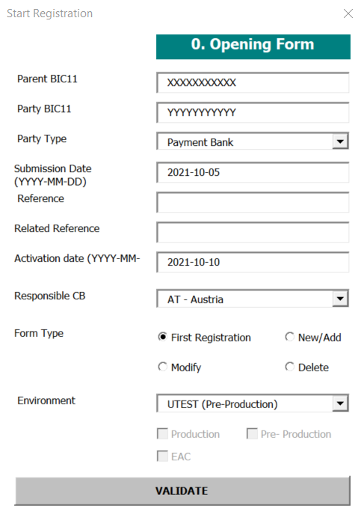
- After clicking on Validate, the user starts to follow the structure of the Form Menu, so starting from 1. Party:
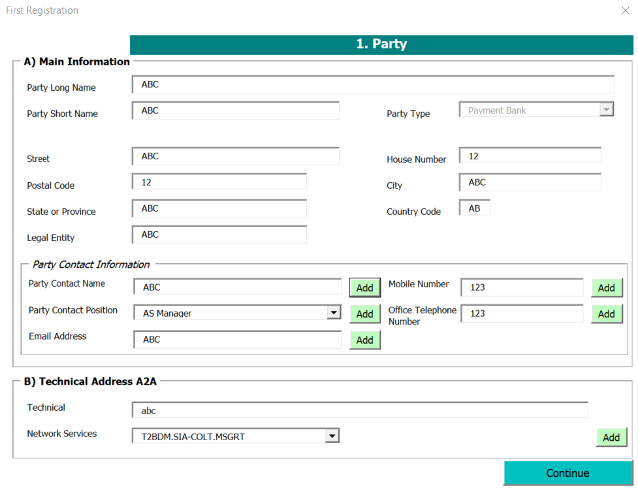
- In this case, the user has previously populated the Add functionality of the ‘Add Contact name’ field, so he must click on Add and Save it again, and click on Continue:
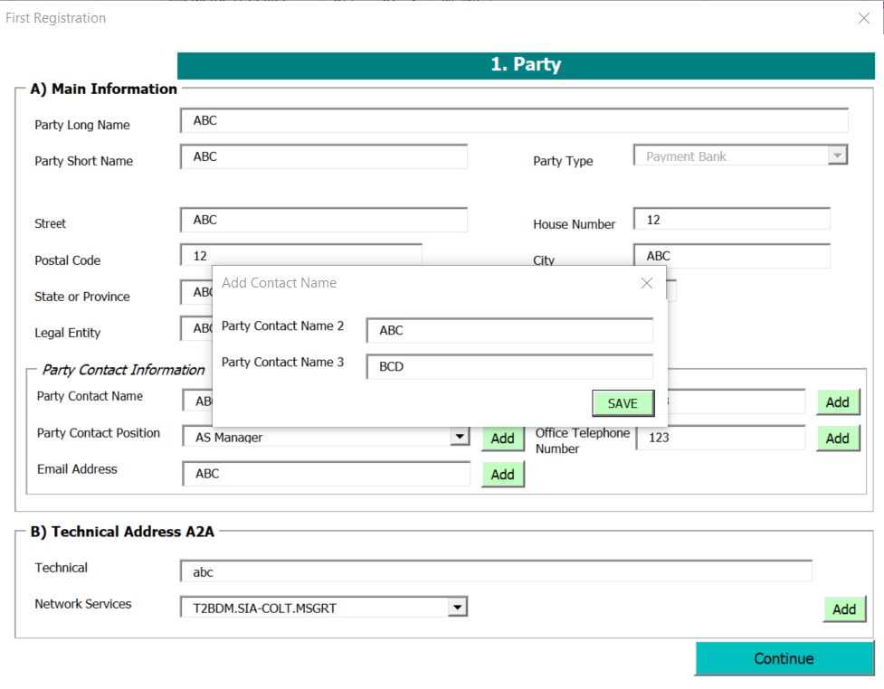
- Then, the section C) Party Service Link is shown, in this case the user did not add any Party Type to link before saving the file, so he does not need to re-enter this field. The user clicks on Continue:
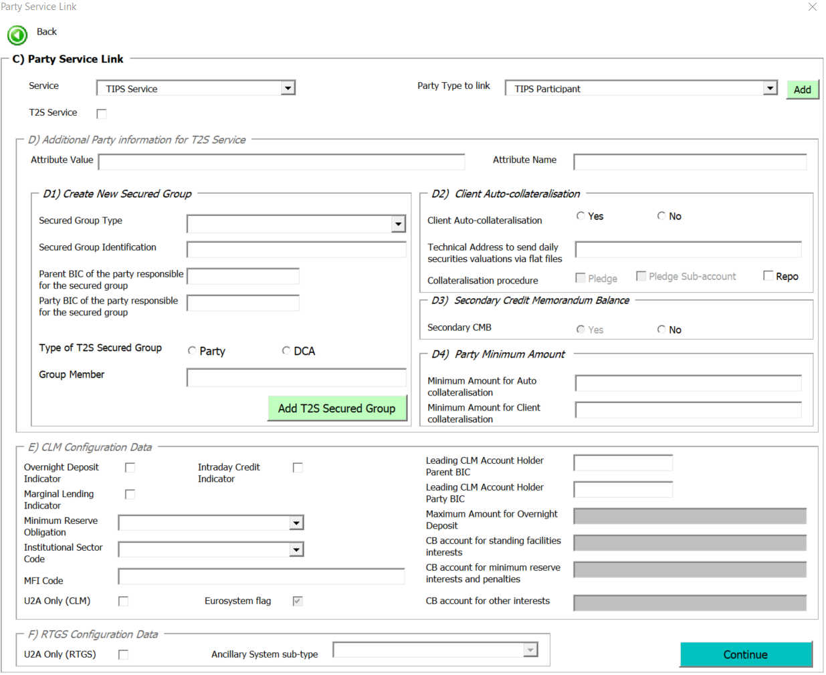
- Next view is shown, and the user just needs to click on Continue:
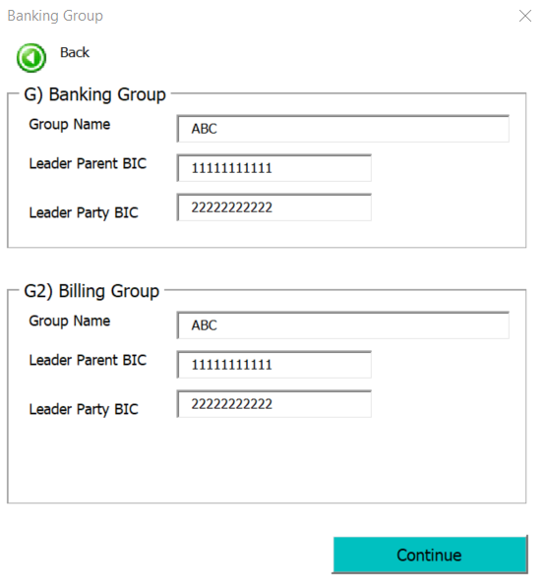
- The user is now able to amend the ticks in the view H) Roles. The user proceeds with the modifications and click on Menu:
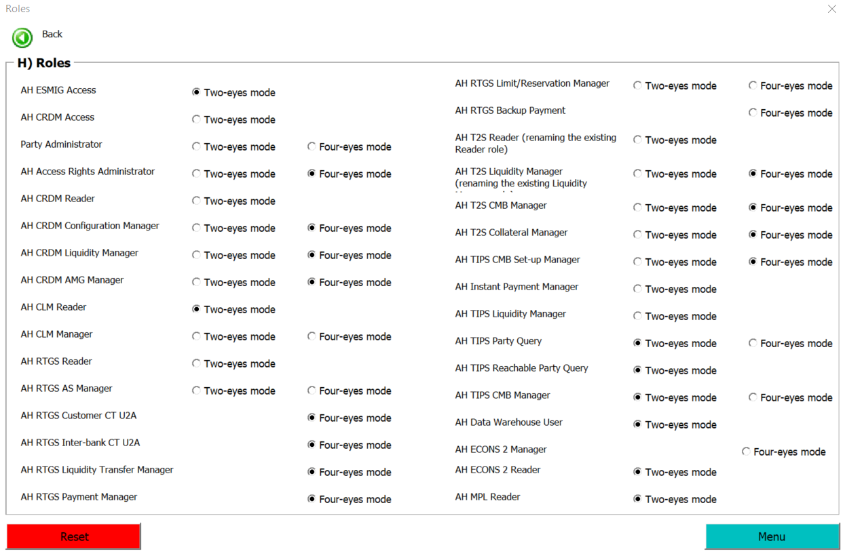
- The user enters the next section following the Form Menu order:
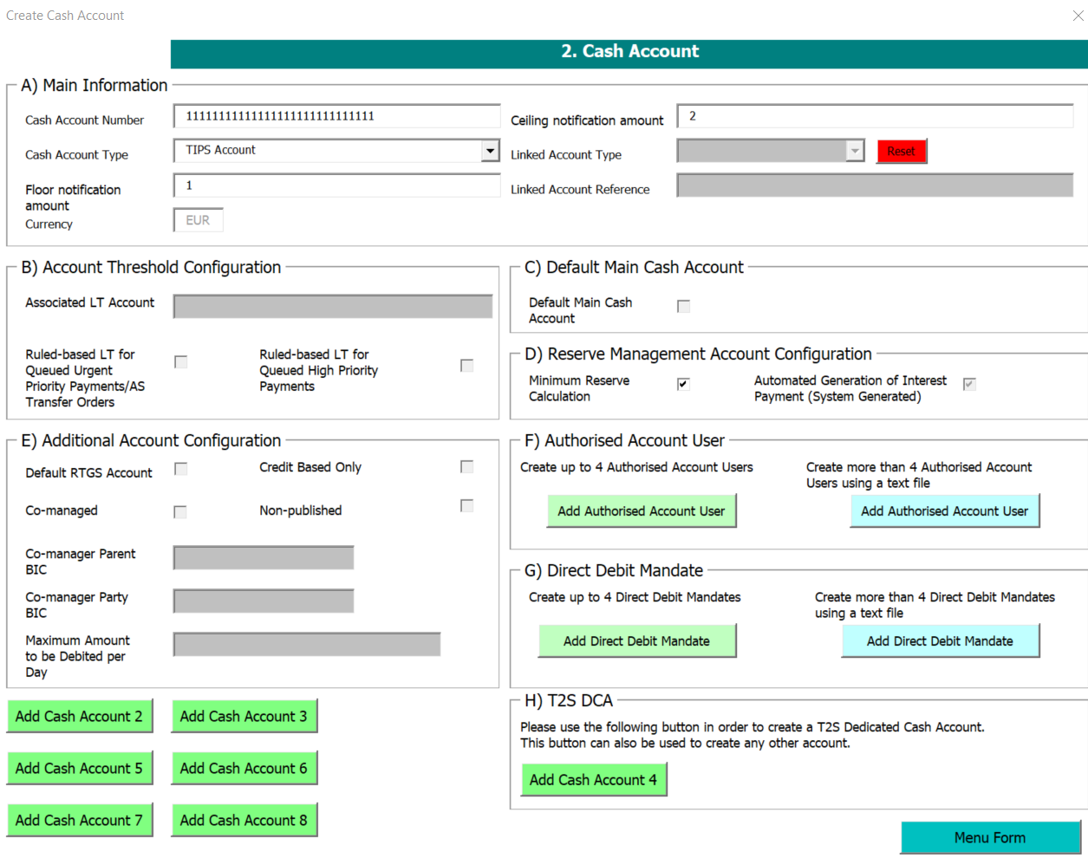
- The user inserts the additional information needed to the section G) Direct Debit Mandate, then click on Save:
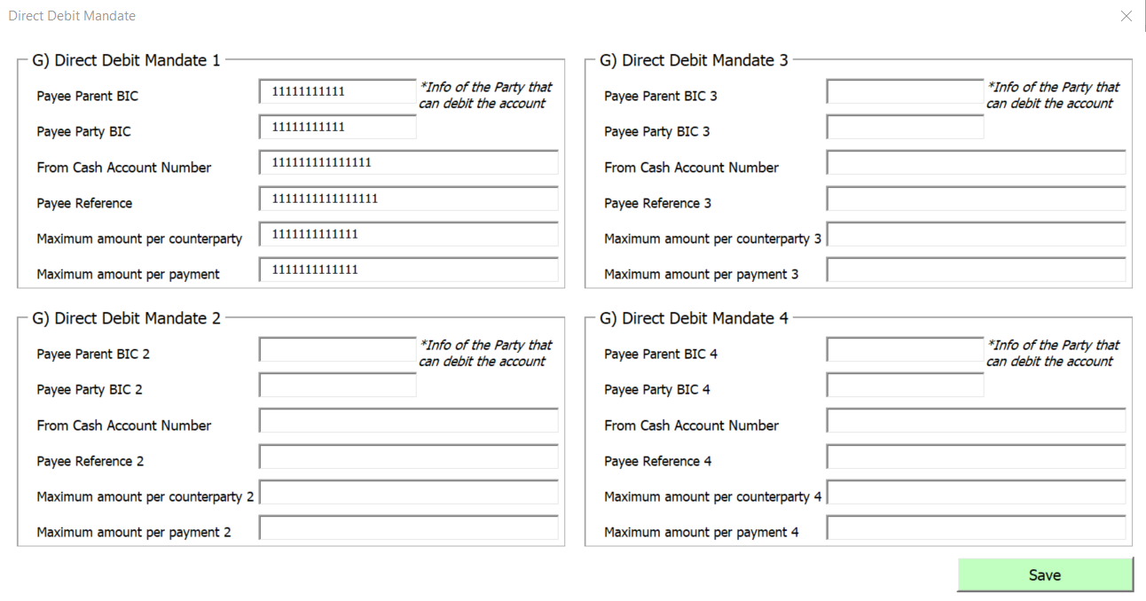
- Before going back to the Menu Form, the user needs to click on Add Cash Account 2, because it was previously filled in and it contains information that needs to be saved again:
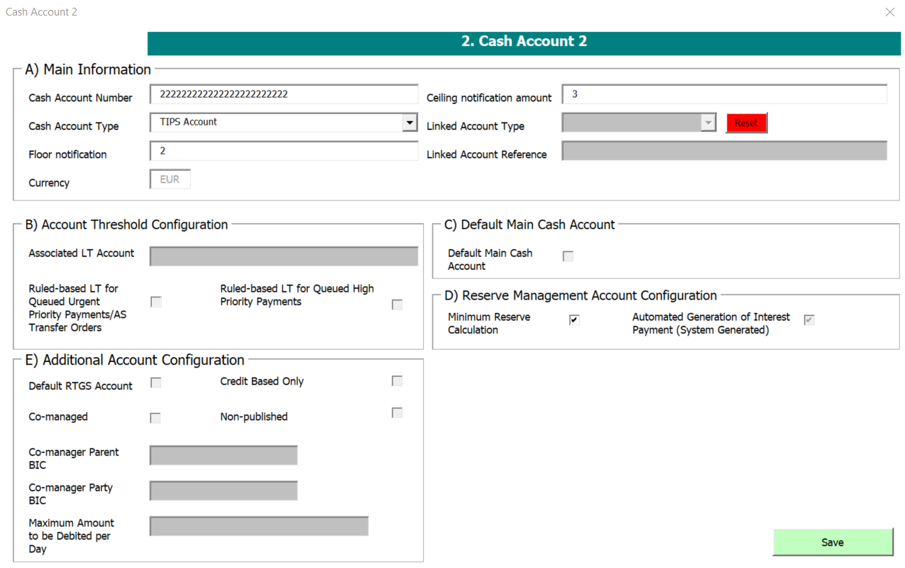
- Once in the Menu Form, the user clicks on 4) Setting Up Administrator User section and, without editing or adding any information, clicks on Form Menu (in this way, the information stored in this section will be saved again in the Data sheet):
